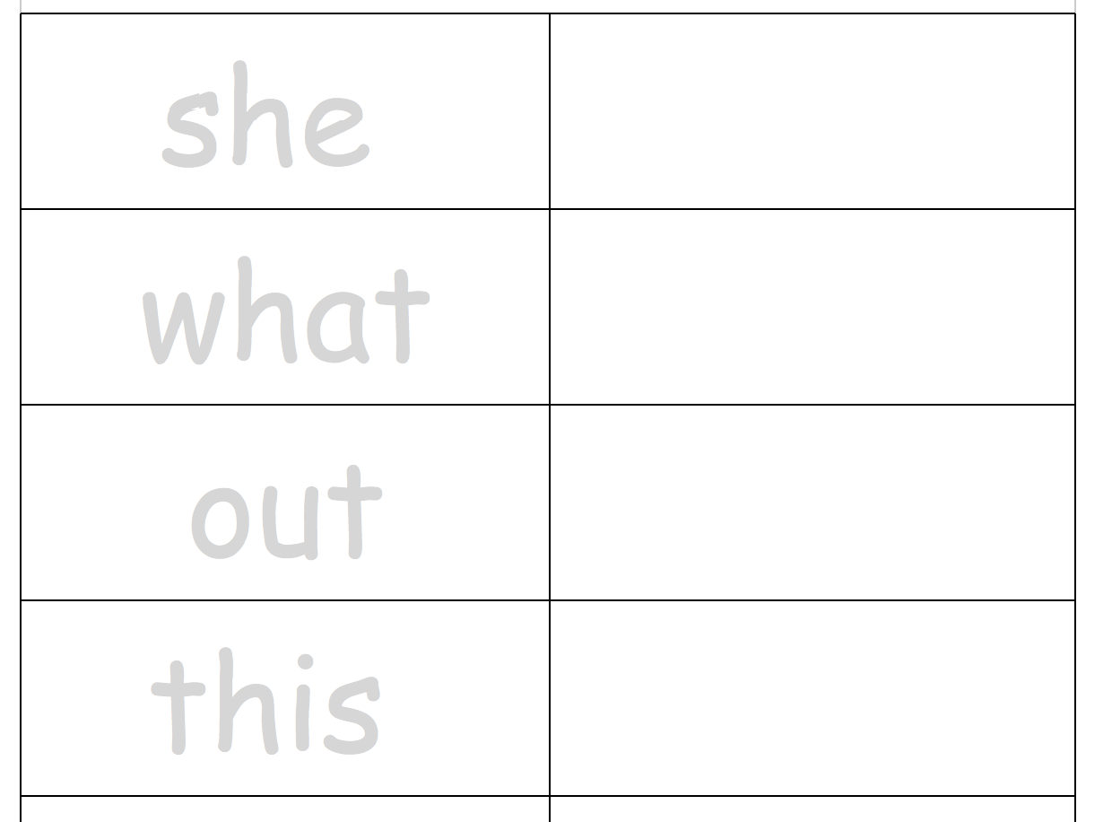

SPELLING AND WRITING
WORKBOOK 2
COMMON WORD LISTS
SPELLING AND WRITING
WORKBOOK 2 Grade 1
COMMON
WORD
LISTS
Table of Contents
First 20 Sight Words 3
Second 20 Sight Words 4
Third 20 Sight Words 5
Fourth 20 Sight Words 6
Fifth 20 Sight Words 7
First 100 Sight Words Puzzles 8
First 100 Sight Words: Competency Test 10
Common Short Nouns And Verbs 11
Sight words for cut-outs 12
Learning Sounds 14
Vowel Diagraphs Competency Chart 18
Similar Sounds Spelling List 19

Copyright Information
This work is licensed under CC-NC-BY
Creative Commons Attribution-NonCommercial-ShareAlike License. http://creativecommons.org/licenses/by-nc /
This text is free for non-commercial distribution and use.
No part of this text may be reproduced for commercial use
without express permission of the author.
Any use of this material must be attributed to:
Free Kids Books – http://www.freekidsbooks.org

NOTE TO PARENTS

These lists are designed to help with the building blocks of reading, individualize and use them as required to achieve fluency.

First 20 Sight Words
Overwrite then copy and learn the tricky sight words

the |  | he
of |  | was
and |  | for
a |  | on
to |  | are
in |  | as
is |  | with
you |  | his
that |  | they
it |  | I

Second 20 Sight Words
Copy and learn the tricky sight words

at |  | but
be |  | not
this |  | what
have |  | all
from |  | were
or |  | we
one |  | when
had |  | your
by |  | can
words |  | said

Third 20 Sight Words
Copy and learn the tricky sight words

there |  | will
use |  | up
an |  | other
each |  | about
which |  | out
she |  | many
do |  | then
how |  | them
their |  | these
if |  | so

Fourth 20 Sight Words
Copy and learn the tricky sight words

some |  | two
her |  | more
would |  | write
make |  | go
like |  | see
him |  | number
into |  | no
time |  | way
has |  | could
look |  | people

Fifth 20 Sight Words
Copy and learn the tricky sight words

my |  | first
been |  | who
its |  | find
day |  | get
made |  | part
than |  | water
called |  | am
now |  | down
did |  | come
may |  | long

First 100 Sight Words Puzzles
Cut out the words and use them as a word puzzle to learn words, here are some ideas to use:
- Cut out two sets and use them as a memory game
- Use the words as flash cards
- Choose nouns and verbs (or use some picture cards), and try to make a sentence with the words (See examples on the following pages)
- Use the pages for a dice game (each time you land on a word and get it right you keep your place, if you get it wrong you go back where you were).
Note: editable versions of this file are available on our MORE page, here: https://freekidsbooks.org/files
the | at | there | some
of | be | use | her
and | this | an | would
a | have | each | make
to | from | which | like
in | or | she | him
is | one | do | into
you | had | how | time
that | by | their | has
it | words | if | look
he | but | will | two
was | not | up | more
for | what | other | write
on | all | about | go
are | were | out | see
as | we | many | number
with | when | then | no
his | your | them | way
they | can | these | could
I | said | so | people
my | than | first | water
been | called | who | am
its | now | find | down
day | did | get | come
made | may | part | long

First 100 Sight Words: Competency Test

The __ | at __ | there __ | some ____ | my __
of | be __ | use __ | her __ | than __
and __ | this __ | an __ | Would __ | first __
a __ | have __ | each __ | make __ | water __
to __ | from __ | which __ | like__ | been __
in __ | or __ | she __ | him __ | called __
is __ | one __ | do __ | into __ | who __
you __ | had __ | how | time __ | am __
that | by __ | their __ | has__ | its __
it __ | words __ | if __ | look __ | now __
he __ | but __ | will __ | two __ | find __
was __ | not __ | up __ | more __ | long __
for __ | what __ | other __ | write __ | down __
on __ | all __ | about __ | go __ | day __
are __ | were __ | out __ | see __ | did __
as __ | we __ | many __ | Number __ | get __
with __ | when __ | then __ | no __ | come __
his __ | your __ | them __ | way __ | made __
they __ | can __ | these __ | could __ | may __
I __ | said __ | so __ | people __ | part __

Common Short Nouns And Verbs
Read then try to add your own words to the list.
Cover and spell to test competency. Or print and cut out, use them with the sight words list to make sentances.
NOUNS
dog | bat | rug | bird | rose
cat | car | box | ball | cake
pig | bus | can | book | star
rat | cow | pan | home | tree
hat | hen | pot | rope | hand
cup | bag | pin | soap | Boat
fox | lid | rag | door | coin
VERBS
play | skip | talk | walk | go
swim | jump | call | sit | try
run | hop | cry | hit | sleep
ENDINGS |  | -ing | -ed | -s
- ly | - ful | -ied | -ies | -es

Sight words for cut-outs
the | at | there | some
of | be | use | her
and | this | an | would
a | have | each | make
to | from | which | like
in | or | she | him
is | one | do | into
you | had | how | time
that | by | their | has
it | words | if | look
he | but | will | two
was | not | up | more
for | what | other | write
on | all | about | go
are | were | out | see
as | we | many | number
with | when | then | no
his | your | them | way
they | can | these | could
I | said | so | people
my | than | first | water
been | called | who | am
its | now | find | down
day | did | get | come
made | may | part | long

Learning Sounds
The sounds below are from the British Grade 1 syllabus.
AY | OY | AI | OI | AR
play | boy | rain | coil | car
day | toy | pain | coin | start
way | joy | wait | soil | park
play | annoy | chain | spoil | garden
say | enjoy | mail | join | arm
stay | coy | snail | oil | dart
a_e | e_e | i_e | o_e | u_e
ate | eve | hide | those | june
late | theme | ride | rope | dude
hate | complete | hive | hope | rude
take | these | side | hose | tune
made |  | five | nose
came |  | like | home
same |  | time
EE | EA (ee) | EA (e) | er | Er (u)
tree | bead | dead | her | better
see | meal | beard | term | summer
seem | seam | bread | verb | winter
need | team | instead | person | sister
seed | read | read
week | deal
green | real
Long oo | Short oo | oa | oe | ou (ow)
moon | book | boat | toe | out
food | look | road | foe | about
 | foot | coach | goes | shout
 | wood | goal |  | mouth
 | good | coat |  | around
 |  |  |  | sound
ow (au) | ow (oe) | ue | ew | ew (yu)
now | own | blue | flew | new
cow | snow | clue | new
how | go |  | crew
brown | blown | Ue - yu | drew
down | show | cue | threw
town |  | Tuesday
ie (long i) | ie (long e) | igh | or | ore
pie | chief | high | for | more
lie | thief | night | short | score
tied | movie | bright | born | before
cried | field | tight | horse | shore
 |  | sight | morning | wore
air | ear | are | aw | au
fair | fear | dare | saw | author
air | near | bare | draw | august
pair | bear | care | dawn | sauce
hair | hear | hare | crawl | nautical
chair | tear | scare | yawn
 | wear | share

Tricky Consonants
/s/ | /j/ | /sh/ | /zh/ | /ch/
sc- | giraffe | sheep | -ge | -ture
ci- | gym | chef | -sion | ch-
ce- | fridge | -tion | -sure | -tch
cy- |  | -cian | -zure
ps- |  | -sion

Vowel Diagraphs Competency Chart

Grade 1 reading list Digraph Vowel Sounds Competency Chart (British Curriculum )
ai | oi | ay | oy | a_e | e_e
i_e | o_e | u_e | ee | ea (e) | Ea (ee)
er | ir | ur | ar | Short oo | Long oo
Er (ur) | oa | oe | ou | ow (o) | ow
ue | ew | ie (igh) | ie (ee) | or | ore
aw | au | air | ear | are | eer

Similar Sounds Spelling List
Short vowels
a | e | i | o | u
apple | egg | hit | hot | nut
hat | head | gym | salt | son
 | said |  | watch | touch
 |  |  | qualify | above
Long a | Long e | Long i | Long o | Long u
play | sweet | kite | rope | glue
pain | eat | night | toe | moon
sleigh | key | tie | dough | juice
cake | movie | fly | plateau | flute
prey | baby | cycle | boat | crew
sundae | theme | eiderdown | snow | soup
break | neice |  | sew | move
 |  |  | so | through
 |  |  |  | super
 |  |  |  | to
oo-short | y-oo | ow | oi | /air/
book | cue | now | coin | hair
could | new | cloud | toy | hare
 | unicorn | plough |  | hear
 | tube |  |  | here
 | you |  |  | deer
 | pneumatic |  |  | cashier
/aw | er | er (u) | ar
snore | term | mixer | artist
oar | birth | humour | father
dawn | nurse | theatre | palm
sauce | earth |  | half
fork | world
water
four
door

More files like this one available at http://www.freekidsbooks.org

This file may be shared, modified, and used unrestricted in any private, non-profit, or educational use, providing the header and this attribution page remains on this file.
No commercial use of this file is permitted.

Find lots more worksheets and books like this one at

http://www.freekidsbooks.org

The font used here is available free at:
http://www.OpenDyslexic.org
Clipart is available free at:
http://www.openclipart.org

