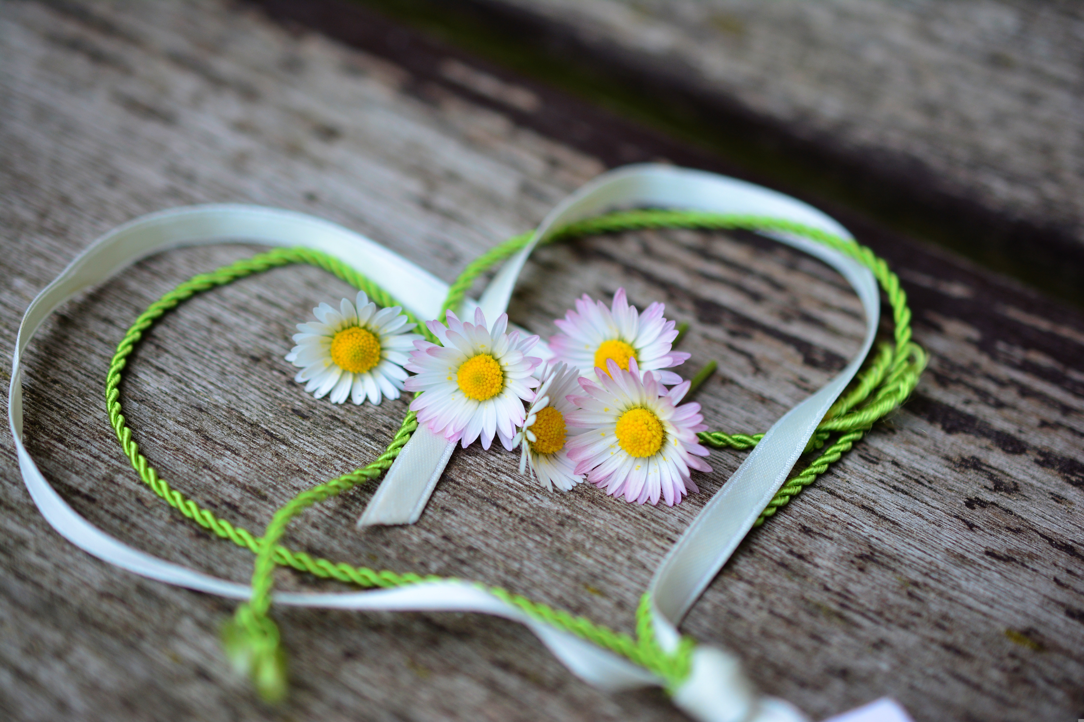

MAX and KEIRA
MAKE A CHANGE
Free Kids Books

Max & Keira Make a Change
Written and Published by Free Kids Books

This work is in the Public Domain.

ISBN: 9798372514027

THIS IS A WORK OF CREATIVE NON-FICTION. THE STORY ABOUT MAX AND KEIRA'S LAW IS TRUE HOWEVER THE BACKSTORY WAS CREATED FOR THE BOOK AND DOES NOT REFLECT ANY TRUE DETAILS.

If you use this book, which has been specially formatted by Free Kids Books, –we appreciate your attribution to:
http://www.freekidsbooks.org

Contact the Publisher:
Danielle Bruckert - danielle@redskyventures.org

More books like this one are available at
http://www.freekidsbooks.org

INTRODUCTION

This is a story about a girl called Keira and a boy called Max. Although Max and Keira had never met, they will become very close, and together, change many lives.

Keira was a happy child, she had a mum and dad that she loved, two older sisters and a younger brother, all of who she adored. Life was very happy and normal. Keira enjoyed playing with her friends and attended a local primary school like most kids her age.

With four kids there were plenty of squabbles, but Keira was a most kind child and if there were fights over things like sweets, Keira would always give her last ones away.

Max was also a fun loving and caring boy. He also loved playing with his friends and going to school, but lately Max had been very sick. He was constantly out of breath and had frequently become too weak to attend school. Max continued school online when he was well enough, sometimes he couldn't attend all together.

HOPES AND DREAMS

Keira dreamed about maybe becoming a veterinarian as she loved animals and when her dog became sick the vet helped him out. She thought it would be so cool to help animals. Other times she thought it would be great to be a marine biologist and perhaps go to Antarctica, she loved swimming in the sea, when the brief English summer was in full force, and loved all sea creatures, especially the seals.

Max dreamed about going to university one day and majoring in political science, ethics, and industrial psychology. He thought these fields could help him make a difference. He sometimes dreamed about becoming a pilot and soaring through the skies, maybe as a profession, but more likely as a hobby. However, most days he just dreamed of being alive. Max had discovered the reason he was always out of breath, always tired. He had a life-threatening heart condition.

WAITING

Max was told by the doctors that he needed a heart transplant, and this was the only way he would get better. But he was also told this may take time and he and his family would need to be patient and wait. While Max was waiting, he began thinking and asking his parents lots of questions.

“Why does it take so long to find a donor?” Max asked his mum.

“Not everyone knows how important it is to donate organs,” she told him, “also the organ needs to be a match.”

This got Max to thinking more, he wondered why someone wouldn't donate their organs, after all, they don't need them anymore. Why wouldn't someone want to help others in their passing? He went to his mother again, “Why doesn't everyone know and decide to donate their organs?” she just shrugged her shoulders. “Do they think they can still feel pain?” he laughed. Then he looked seriously at his mother, “We need to make them understand.”

Mum just laughed, “Now, Maxie,” and she tickled Max in the ribs, “Just how do you think you’re going to achieve that.” They both laughed together. “Perhaps there needs to be more publicity. If people who have been helped by donors went on TV or the Internet, saying they were only alive because of a generous donor. That might help the cause.”

Max didn't just lie and wait. He thought long and hard. He looked up information about organ donation online and thought about how he might be able to help promote this further. Then more people would want to donate and the waiting lists wouldn't be so long. He thought of all the people like him waiting for organs and how unfair it is. He thought about people not knowing how important organ donation is and that they probably would donate if they knew how important it is. Max closed his laptop, ‘I guess most people might have simply never considered it or at least never told their loved ones. That’s sad,’ he thought.

A PLAN WAS FORMED

Max's resolve deepened one day when he asked where a girl he had befriended was, who he saw regularly in the paediatric hospital. He was told she just didn't make the wait.

Back at home, on his tablet, Max found out that people in some countries can opt-in for donation on their driver's license. “THAT ISN’T ENOUGH,” he shouted at the picture of his school football team hanging on the wall in front of him, “Nowhere near enough. It's too difficult.” Then he read about Spain. In Spain they have the highest rates of organ donation in the world. Why? Mainly because of an opt-out law since 1979. “What if there was an opt-out law rather than an opt-in law here in the UK?”

IN THE MEANTIME

Keira, in the meantime, was enjoying her school holidays and was looking forward to visiting her grandparents in another part of the country. It was not too far away but would be a long car trip.

She carefully packed, for the week away, her favourite clothes, her favourite toys, and a present she had made for her grandmother, a necklace out of seashells. She was very excited about the trip. She was going with her mum and brother. Her older sisters were studying for exams and her dad had to work. ‘She would miss them,’ she thought, ‘but not too much.’ There was lots of fun to be had with her grandparents who lived on a farm. She would enjoy baking with her grandma, as she was the best baker, and she always let Keira lick the bowl. Her grandad always told her lots of fun stories and let her help with the animals. Their grandparents also had a lovely garden with roses and vegetables which always looked so perfect. When Grandad taught her how to tend the garden she dreamt of having one of her own one day. The family apartment only had a small terrace, she wondered if she would have a house with a garden, or maybe even a farm like her grandparents.

THE CAMPAIGN

While Max was still waiting to hear if he would receive a heart, he had lots of time alone as he wasn't well enough to play and couldn't do much apart from read, so he read more and more about organ donation and organ donation laws. When he told his Mum and Dad about his idea on 'opt-out' laws, they encouraged him, and his excitement grew. Max's Mum and Dad had not seen him so excited since he first became sick and the whole family got to work helping Max with the goal.
Max researched some more and found out that he could campaign his local MP to have a change of law put on the agenda for parliament. They could make a petition and if enough people signed, the government would need to listen. His thoughts wandered to what it would be like to get the bill through parliament, would the press cover it? Would there be lots of people there to celebrate?

Max's family decided to contact a newspaper to help in the campaign. They found a reporter at The Mirror who wanted to help. Max explained to him about his idea for opt-out rather than opt-in organ donation law. The reporter researched and found that many other countries that had passed the opt-out laws with increased successful organ transplants as a result. He ran an article, interviewed Max, and then they sat down together and worked out a plan to make the campaign successful; to totally create more awareness throughout England. The reporter helped Max draft up a petition and the paper published details.
Before long, it seemed Max was not the only one who thought this was a great idea and, with the help of the newspaper and lots of effort from all the family, soon there were thousands of signatures supporting the new law. Max was so wrapped up in the campaign, he almost forgot about the long wait he was enduring, and the months flew by.

A TRIP

The day was finally upon her, despite the long road trip ahead, Keira's spirit was high. She packed her tablet for keeping busy on the road and her Mum packed some snacks and drinks. After saying all their goodbyes to Dad and big sisters, around 8am they set off, wanting to get to their destination in time to unpack before lunch. The trip was uneventful asides from her little brother being generally annoying, which was to be expected, especially in close confinement. She loved him, but she had forgotten what it was like to be little now that she was in upper primary.

SUDDENLY EVERYTHING CHANGED

Before Max could finish the campaign, Max and Keira's lives would meet and change their world forever.

Out of the blue Max's Mum got the call she had been hoping and praying for these long months, which she knew her son needed so desperately. They had FOUND A HEART!

At the same time as being ecstatic, she was deeply fearful, she didn't think the mix of emotions could be so chaotic. While she had prepared herself for so long, she still knew the risks, Max had to go through a lengthy and dangerous surgery, and there was still a chance of the body rejecting the organ.

***

In the sister hospital to the paediatric facility where Max had spent a good part of two years, Keira's mum woke up paining all over. What the h#$l had happened, the thoughts rushed through her mind. The last thing she remembered was chatting with Keira about what Grandma might be cooking for lunch while minding the traffic along the freeway. Now the smell of disinfectant, the colours, the bed, and the pain, had there been an accident? She simply couldn't remember, and where were her children?

Keira's mum’s worst fears were confirmed when a nurse appeared, “There was an accident.”

The nurse explained to Mrs Ball that she couldn't give her any more details but assured her that her husband would be along soon.
After what seemed like an agonising few hours, Mr. Ball appeared. She knew from the look on his face the news was not good. While she was still unconscious, both her kids had been fighting for their lives. There was no way to say it without pain, and it would blindside Mrs. Ball so badly that she forgot all about the pain she herself was in.

Keira didn’t make it.

KEIRA LIVES ON

In one part of the hospital a family was preparing for a funeral; in another part of the hospital a small boy was fighting for his life under a surgeon’s scalpel.

Keira’s family had received a request that couldn't wait. Could Keira, always helpful in her life, be helpful one more time in her passing? The Ball family never hesitated. They knew it was what Keira would have wanted.

***

The operation was successful, and while still in incredible pain, since in heart surgery the surgeon must break the ribs along with all the other sewing and cutting, Max couldn't be happier. After a time, Max was finally allowed to go home, but they were not out of the woods yet. Now the family waited on edge to see if Max would recover, or if his body would reject the new heart.

Days went by, then weeks, and gradually Max became stronger and stronger. And while he was looking forward to all the things he couldn't do while he was sick, like playing with his friends again and going back to school, Max hadn't forgotten the wait and made a promise to himself to keep going with his campaign to help make donors easier to find, to try to make a difference so that others could be as lucky as he was. Max never met Keira, but he would never forget her. She was the reason he had a second chance at life.

MAX AND KEIRA – A LEGACY

Although Max and Keira never met, they had become permanently intwined, and together would change many lives.

On the 20th of May 2020, almost 4 years after Max began supporting the opt-out initiative, a new law was passed in the UK. They called it Max's Law. But Max told them it wouldn't have been possible without Keira and her family, and from then on, the law was dubbed "Max and Keira's Law". The law was a tribute to the contributions of Keira in her passing and for Max's tireless efforts and achievements during his illness to help make a difference to all those on donor waiting lists.

Max and Keira's Law is based on an opt-out rather than an opt-in system. From this point on, everyone living in the UK who is over the age of 18, who is not in an excluded group, and who has not gone to the effort of "opting out" will be required to donate their organs on passing.

In 2021 alone, the new law saw 296 more donors, which wouldn't have been possible without it. This resulted in 714 people who had their lives saved by Max and Keira's law, an over 25% increase in transplants. And every year the number of additional lives saved will grow.

EPILOGUE

Countries that have adopted the “opt-out” donor laws have some of the shortest waiting times and the highest number of successful transplants.

We have created this book to spread awareness because we believe all countries should have opt-out laws. If you want to help, find out about your country's donor laws, and if you don't have an opt-out law, get in touch with the national organ donation organisation, and the media and see if you too can make a change like Max and Keira did. If you want support, please do get in touch with us at the details provided on page 2.

To donate to the charity set up by Mr and Mrs Ball, Keira's parents in her memory, see: https://www.facebook.com/inspiredbykeira/.

- THE END -
For some,
for others, a beginning...

ABOUT THE AUTHOR
Danielle Bruckert

Danielle is a New Zealander living abroad, who now calls Africa home. Her chosen career is as a professional pilot, she has worked in a variety of aviation capacities from instruction to airline flying, and is the author of several aviation text books.

Danielle started writing children's books as a creative outlet from the intensity of her 'day job' and as a break from the sometimes monotonous work required for her professional writing. She began with the Mac and Dipper series, aimed at 5-10 year olds, inspired by two of her own dogs. After having children of her own, she suddenly found she had a muse, an eager resource for test reading, and, by benefit of age, honest critics all in one, it was fun and rewarding to write creative stories which matched her children's learning curve, and this combined a fun hobby with great family time.

Because of her passion for children's literature and it's role in improved literacy standards, all of Danielle's own books are available for free download and may be used free of charge for non-commercial purposes. Finding no where to share children's books specifically online and feeling sure there were others out there with the same need, this passion led to the creation of the popular website Free Kids Books where there is now over a thousand free children's books shared.



https://www.freekidsbooks.org
Simply great free books -
Preschool, early grades, picture books, learning to read,
early chapter books, middle grade, young adult,
Pratham, Book Dash, Mustardseed, Open Equal Free, and many more!
Always Free – Always will be!

Free – REALLY?-

Legal Notice: This book is in PUBLIC DOMAIN- YAY!!! That means you can reuse it in pretty much any way you wish. We greatly appreciate if you credit to us as a source by including a link to our site, https://www.freekidsbooks.org, on your post or end product, or simply leave this page in tact, so more people can enjoy great free books. Please reach out and contact us at https://www.freekidsbooks.org/about if you want more information, or want to share your project with us, so we can help with promotion. Please, enjoy this, and our many more free kids books!

