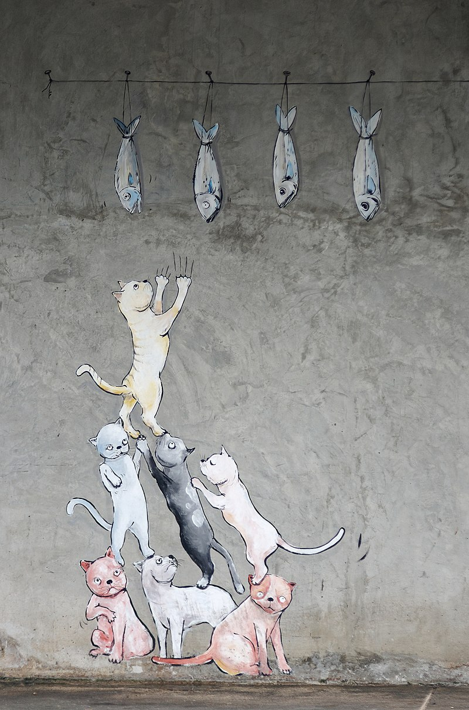
MORE
Conversations Among Cats

Overheard by Gabriel Rosenstock

Cover Photo: Jakub Halun
20171106 Cats Chiang Mai 0178 DxO - Category:Paintings of cats - Wikimedia Commons

Book 1, Conversation with Cats, available here:
https://freekidsbooks.org/conversations-among-cats/

Text: CC-BY-NC
Images: Public Domain
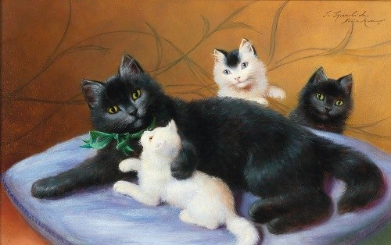

Sophie Sperlich
https://mdl.artvee.com/sftb/702808an.jpg

‘Hey, look! I’ve just caught a mouse! A big white mouse!’
‘Oh no, you haven’t!’
‘Oh yes, I have!’
‘Oh no, you haven’t!’
‘Oh yes, I . . . I haven’t?’
‘No! I’m not a mouse!’
‘You’re not a mouse?’
‘No! I’m a kitten.’
‘A kitten? I don’t believe it. Say MEEOW!’
‘MEEOW!’
‘Again, please?’
‘MEEOW!’
‘Oh . . . you are a kitten. Sorry about that!’

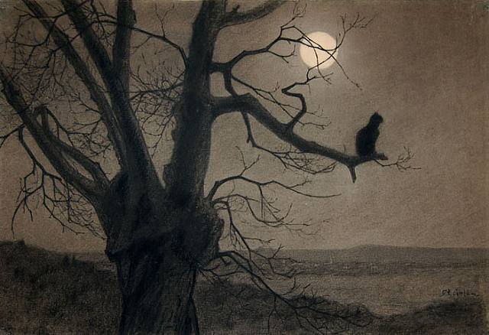

cat-in-the-moonlight.jpg (640×438) (wikiart.org)
Théophile Steinlen.

I feel ashamed! Imagine not knowing the difference between a kitten and a mouse. What’s wrong with me? I don’t know. I really don’t know. Maybe I don’t think hard enough.

Or maybe I just think too much. Is that it? Yes, that’s it . . . maybe. Well, I can’t just sit here thinking about it all night, can I?

I mean, a kitten and a mouse – they don’t even smell the same!

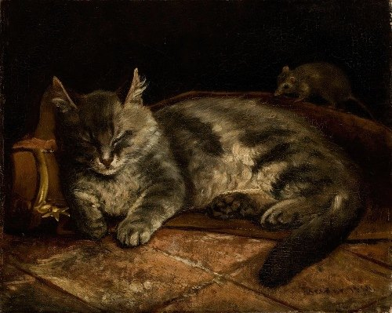

Adolf von Becker
https://mdl.artvee.com/sftb/700671an.jpg

My name is Susy and . . . oh, I think I’m falling asleep. Could we have this conversation some other time, please?

Yes, I’m definitely falling asleep. I hope I don’t start dreaming about that rat again.

Rats! I can’t stand them . . .

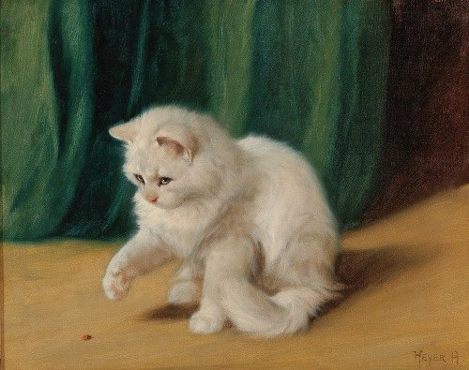

Arthur Heyer
https://mdl.artvee.com/sftb/701107an.jpg

Hello, good meeowning to you! May I introduce you to Lola, my pet ladybird. She’s something else, isn’t she? All the other cats are so jealous.

I have to be very gentle with Lola. She’s rather delicate.

By the way, do you know what you are supposed to say when you catch a ladybird?

Fly away east
Fly away west
And show me the cat
That I love best!

My grandfather told me that one.

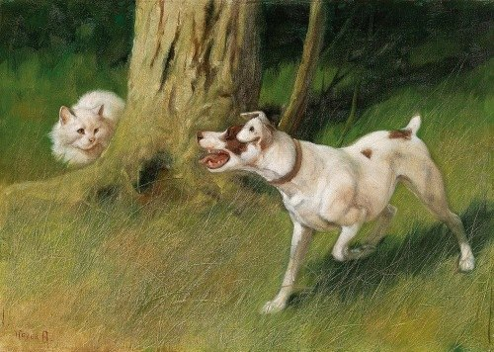

Arthur Heyer
https://mdl.artvee.com/sftb/701110an.jpg

Tell me. Honestly! What do you think of dogs? Do you think they are . . . what shall I say, necessary? Really, really necessary? I don’t know. I doubt it.

I’m going to make a list of things that are really, really necessary. Dogs won’t be on that list, I’m afraid.

Dogs! They think they’re awfully clever. Don’t they? They can’t even say ‘Meow!’

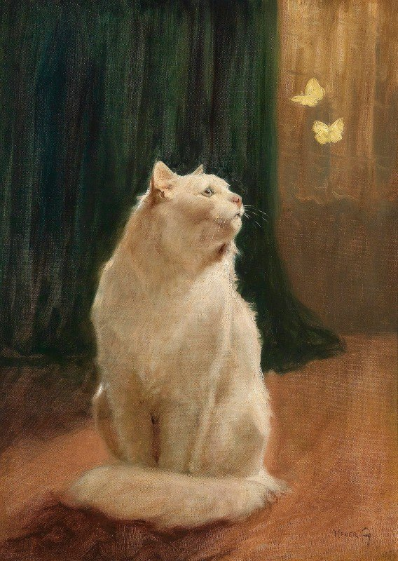
Arthur Heyer
https://mdl.artvee.com/sftb/701104an.jpg

OK, you want to know what’s really necessary? Meow! Butterflies!

Can you imagine what the world would be like without butterflies? Seriously! What kind of a world would that be?

When I was small, I thought butterflies were made out of butter. On hot days, I wondered why they didn’t melt! Meow!

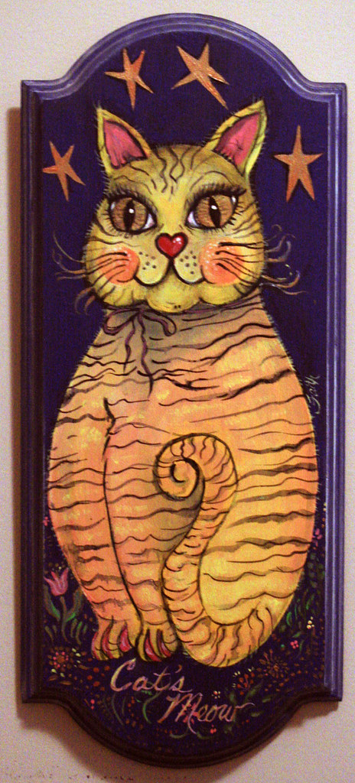
Faith Goble
Cat's Meow (painting) Cat (poem after Carl Sandburg's 'Fog') | Openverse

My name is . . . actually, I’m not allowed to say. Seriously! It’s all very hush-hush. You know, classified!
Some people know me as Question Mark, or QM for short. My tail is supposed to look like a question mark. Meow!
I’m from a place called Oweynagat. If you were from the West of Ireland, you would know that Oweynagat is code language. The place was originally known in Irish as Uaimh na gCat, or the Cave of the Cats.
Now, what can I say about Oweynagat? I could say a lot but, as it happens, I can’t say very much, I’m afraid. You see, it’s all hush-hush, top secret. I’d love to tell you more,
but . . .
Oweynagat is in Co. Roscommon, Ireland, near a place called Tulsk. Oweynagat is like an Irish, hidden-away Langley (home of the George Bush Center of Intelligence, USA) – except Oweynagat is older. Much, much older. Prehistoric, in fact.
OK, I’ve said enough, maybe too much! You won’t hear from me again. A cat may have nine lives, but I’m not taking any chances. This is QM, signing out.

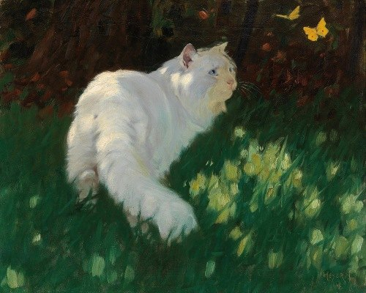
Arthur Heyer
https://mdl.artvee.com/sftb/701112an.jpg

There’s something about butterflies. I don’t know what it is. If you see a yellow butterfly, the days ahead are going to be bright and sunny, believe it or not!

I heard that from my granny! She never told a lie in her life!

Never . . . Meow!

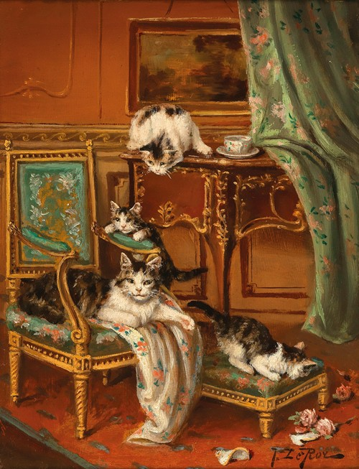

Jules Le Roy
https://mdl.artvee.com/ft/707067an.jpg

‘OK, kitties, its quiz time!’
‘Hurray! Meow!’
‘What do you call a big building to honour cats?’
‘Dunno!’
‘A cathedral!’
‘Oh! Meow!’

‘If a dog bites your tail, what word is used to describe such an incident?’
‘Dunno!’
‘A catastrophe!’
‘Oh! Meow!’

‘Where is the best place to go on a holiday, if you are a cat?’
‘Dunno!’
‘Catalonia!’
‘Oh! Meow!’

‘What is the German word for the river Danube?’
‘Dunno!’
‘Very close. I’ll give you that one. It’s Donau!’
‘Oh! Meow! Meow! Meow!’

‘That’s all for today. More tomorrow. What day is tomorrow?’
‘Dunno!’

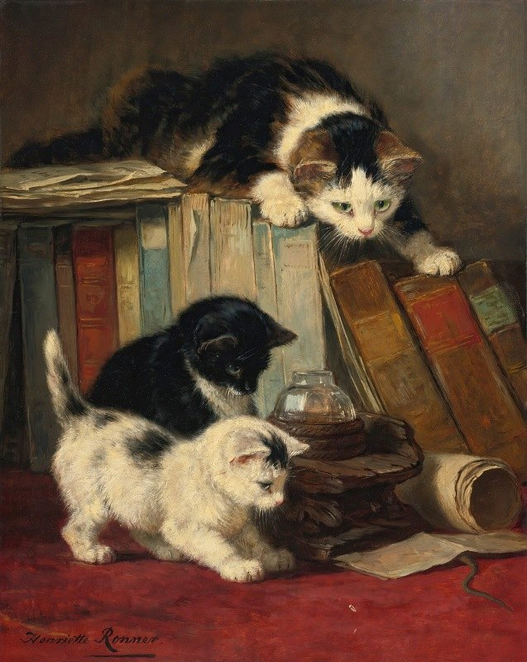

Henriëtte Ronner-Knip
https://mdl.artvee.com/sftb/702512an.jpg

‘Hello? What have we got here?
Now, kitties . . . Listen! Pay close attention!

Shh . . . ‘

‘Meow!’
‘Shhh!’

‘Do this right and we’ll have a tale to tell!

‘Meow!’

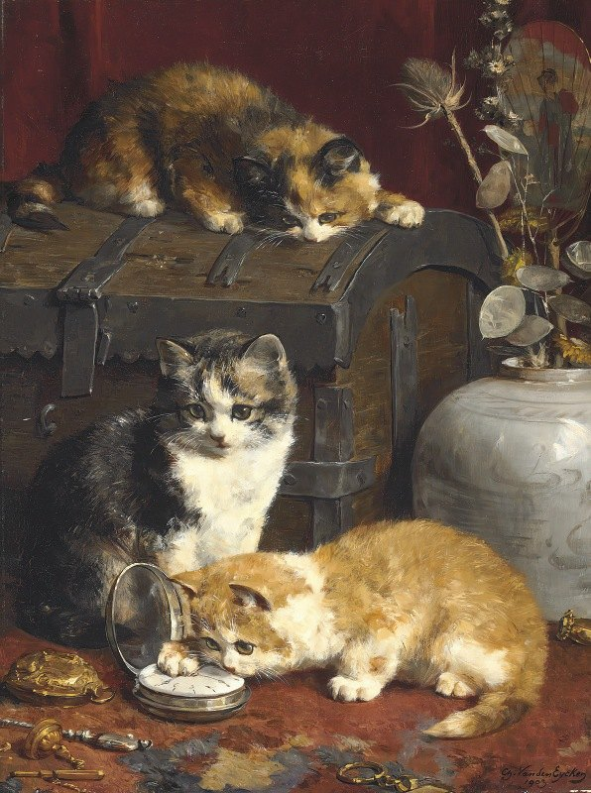
Charles Van Den Eycken
https://mdl.artvee.com/sftb/702292an.jpg

‘What time is it?’
‘What? What time is it?’
‘Yes, what time is it, please? Meow!’
‘It is precisely . . . I don’t know. Why do you want to know?’
‘I might be late. Or early. Meow!’
‘Cats are never late. Or early. Cats are always on time.’
‘Really?’
‘Always. Meow!’
‘I was wondering. What exactly is ‘time’ anyway?’
‘Time? . . . What is time?’
‘Yes.’
‘Well, it’s a bit like parsley, you know?’
‘Parsley? Meow!’
‘Or sage.’
‘Sage? What are you talking about?’
‘Time! I’m talking about time.’
‘What is time?’
‘You could say it’s a bit like rosemary.’
‘First it was like parsley, then sage – and now it’s like . . . Meow! Rosemary?’
‘Have you never heard the song:

'Are you goin' to Scarborough Fair?
Parsley, sage, rosemary, and time,
Remember me to one who lives there
She once was a true love of mine!’

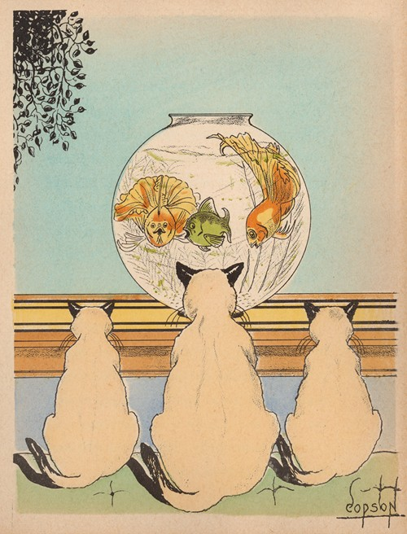
Clyde A. Copson
https://mdl.artvee.com/ft/907357il.jpg

I know. You think it’s boring. I thought the same, at first. But believe me, do this for 20 minutes every day and you won’t know yourself!

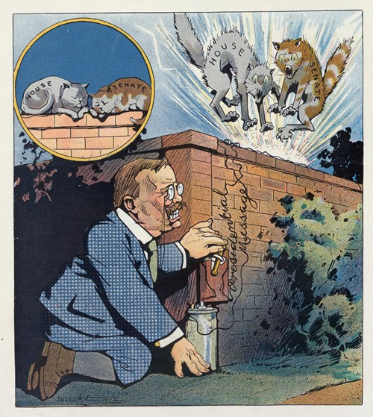

https://mdl.artvee.com/ft/905261il.jpg
Frank Arthur Nankivell

TERRORIST
Known as “Jock the Shock”

Wanted by the CIA
(Cat Intelligence Agency, Oweynagat,
Ireland)

Huge Reward!

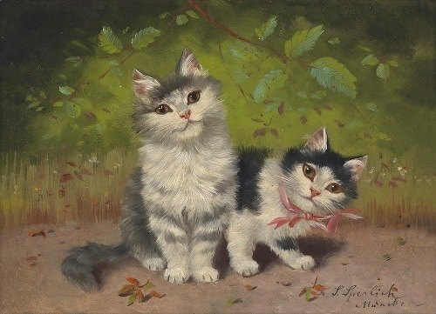

Sophie Sperlich
https://mdl.artvee.com/ft/701507an.jpg

‘Hi there, I’m Peaky!’
‘And I’m Squeaky, the one with the ribbon. We’ve just learned a lovely new song!’
‘Actually, it’s not new. It’s quite old, Squeaky!’
‘Is it? Meow! Anyway, it’s called . . .’
‘Farborough Scare!’
‘No, Peaky! Meow! It’s Scarborough Fair.’
‘Oh yes, thanks, Squeaky. Scarborough Fair! Of course . . .’
‘What a song, Peaky! What a song!’
‘Indeed, Squeaky! Meow! What a song, indeed!’
‘Scarborough! It sounds like a really nice place, doesn’t it, Peaky?
‘Nice, Squeaky? You bet! Terrific! Meow!’
‘They have parsley there, and sage, and rosemary and . . . Meow! They might even have some catnip there as well, Peaky!
‘Catnip? Do you think so, Squeaky?
‘Yeah, catnip, Peaky! Meow! So, friends, we’re off to Scarborough! Wanna come along? Meow!’

END
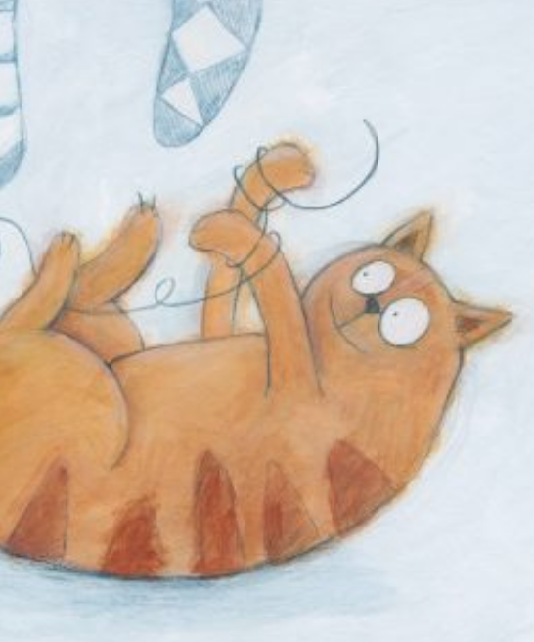

This book is shared online by Free Kids Books at https://www.freekidsbooks.org in terms of the creative commons license provided by the publisher or author.
Want to find more books like this?
https://www.freekidsbooks.org
Simply great free books -
Preschool, early grades, picture books, learning to read,
early chapter books, middle grade, young adult, OER textbooks
Pratham, Book Dash, Mustardseed, Open Equal Free, and many more!
Always Free – Always will be!
Legal Note: This book is in CREATIVE COMMONS - Awesome!! That means you can share, reuse it, and in some cases republish it, but only in accordance with the terms of the applicable license (not all CCs are equal!), attribution must be provided, and any resulting work must be released in the same manner. Please reach out and contact us if you want more information:
https://www.freekidsbooks.org/about

This page is added for identification.
Image Attribution: Karen Lilje, Come Back Cat CC-BY-SA.
YAY!
Totally

