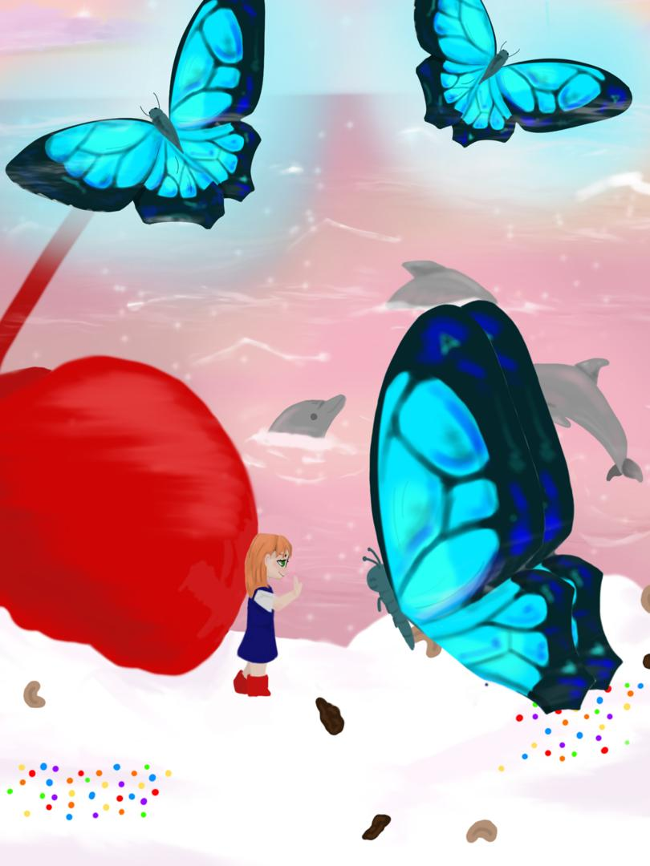

Isobel &
Phaedro the Butterfly

Written by Kiwi Opa
Illustrated by Zehnya

This work is licensed under the
Creative Commons Attribution-NonCommercial-ShareAlike License, CC-NC-BY
http://semi-conservative/licenses/by-nc/4.0/


This text is free for non-commercial distribution and use. No part of this text may be reproduced for commercial use without express permission of the creators.

Creative Commons Licensing Attribution:
Any use of this material must be attributed to:
Kiwi Opa and Zehnya Bruckert


https://www.freekidsbooks.org

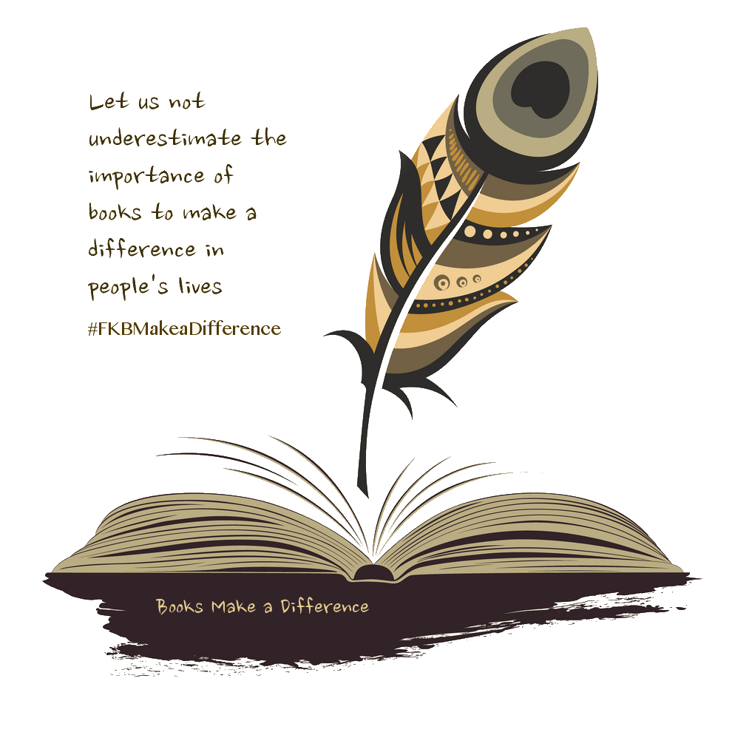

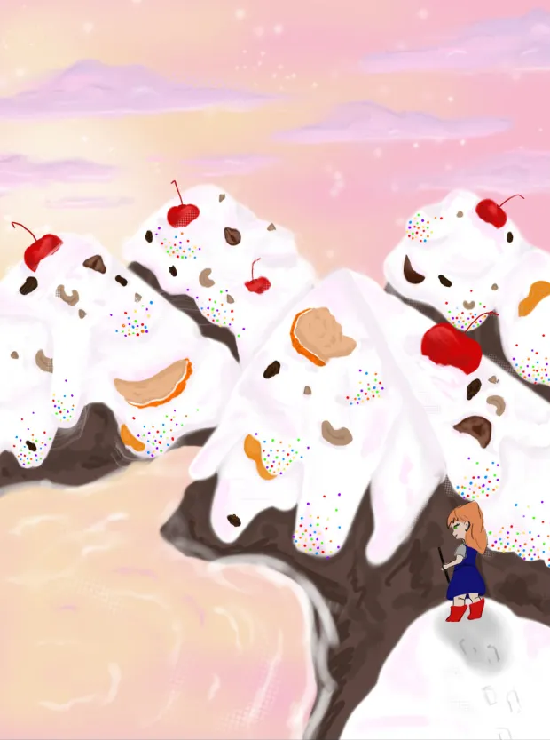

Christmas Cake Mountain
Isobel had never seen a mountain like it! Thick white snow, like icing on a cake, covered its slopes. Sprinkled on top, hundreds and thousands, all the colours of the rainbow. Isobel counted five giant red cherries, two chunky pieces of orange peel, three dried apricots poked up out of the snow. And nuts, all kinds of nuts!

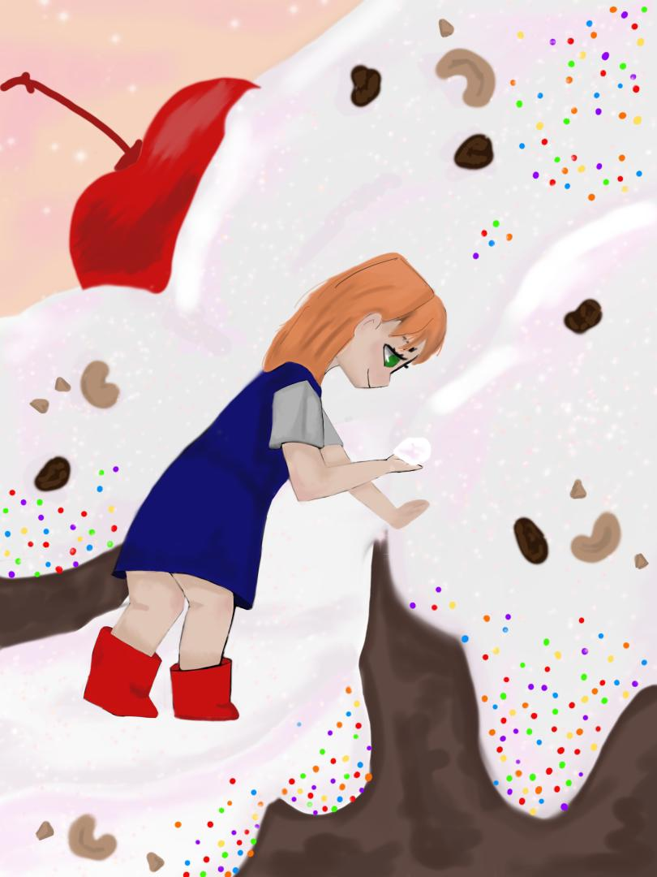

Isobel on the Mountain
She began to climb. She thought she could smell jelly beans in the snow. She licked her fingers. “Wow!” She shouted. “Wow!” The mountain shouted back. “It tastes like goody, goody gumdrop ice cream. “Goody, goody gumdrops,” echoed the mountain.

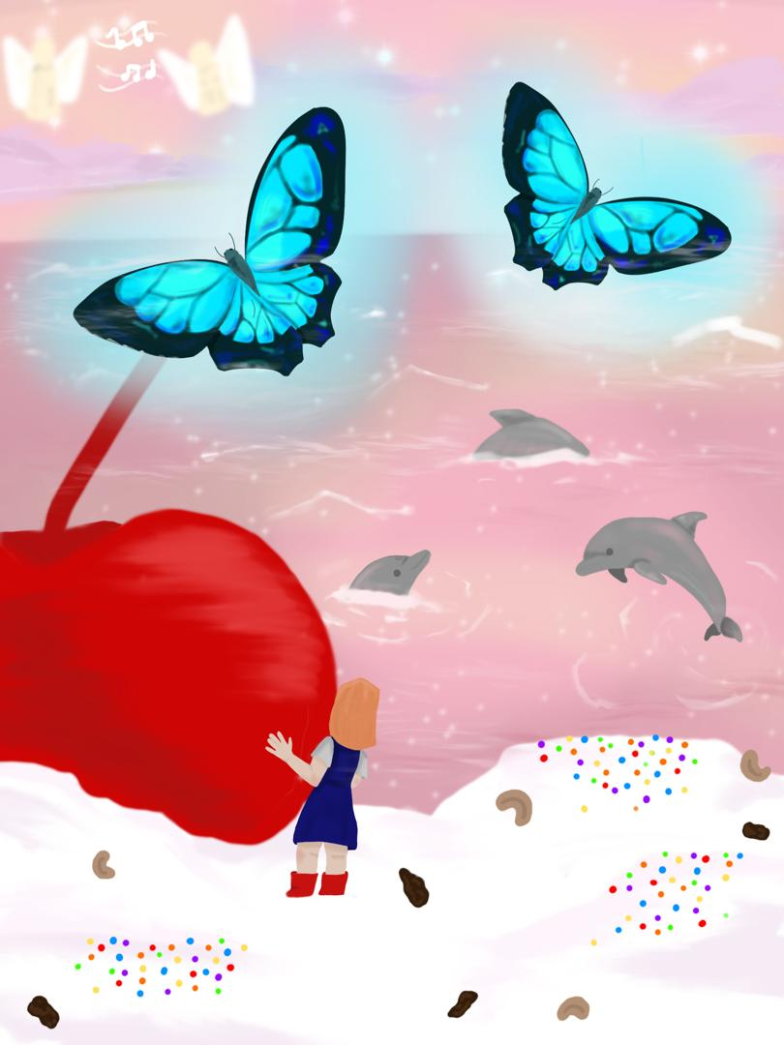

Butterflies, Dolphins, and Angels
Behind a giant cherry, Isobel discovered a beautiful pool of pastel pink water where dolphins swam and played. Fluttering all around she encountered giant butterflies with bright blue wings. And high up above her in the sky heavenly, glowing angels sang peaceful lullabies.

Isobel Meets Phaedra
As she was watching, an awesome butterfly flew down and landed on the back of her hand. “That tickles,” she laughed. The butterfly smiled. He had big eyes and long quivering eyelashes, “I'm Phaedra,” his voice was ever so gentle, “I’ll be your guide. Come, let’s have an adventure.”

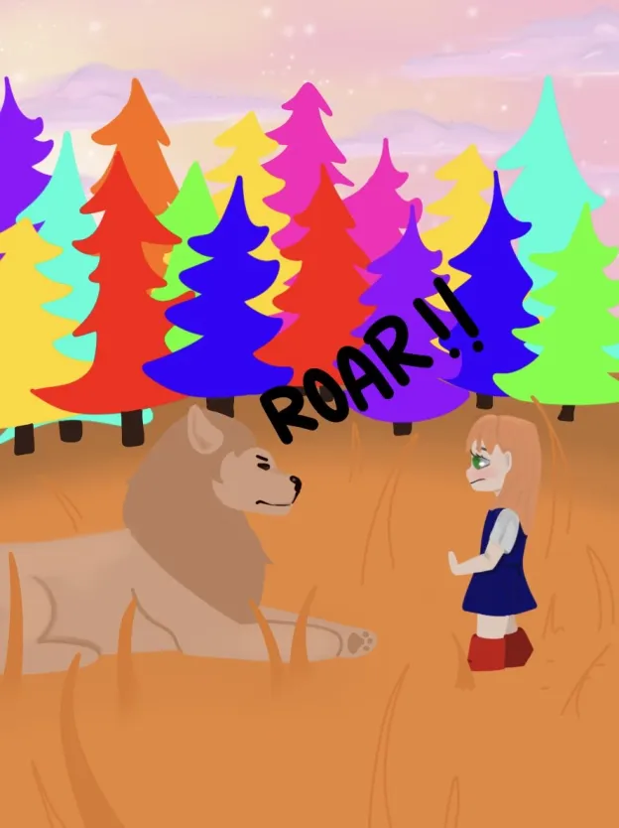

Orange Grass, Green Sky
Phaedro flew off and Isobel raced after him. “Wait for me!” she cried, laughing. Bright sunshine glared at her. She wished she had dark glasses to put on. Although she couldn’t see, she kept on running, her eyes shut tight.
“You can open your eyes now, Isabelle, I have dimmed the sunlight.
She opened her eyes again. She was in a different land. The grass was tall and orange and grew up to her nose. The sun was green and shaped like a heart. And the trees were as tall as buildings. Their leaves, were all different colours: Pink and red, orange and purple, blue and yellow.

“R-----o-----a-----r!” Isobel got such a shock; she flipped a cart wheel. Behind her was an angry lion.

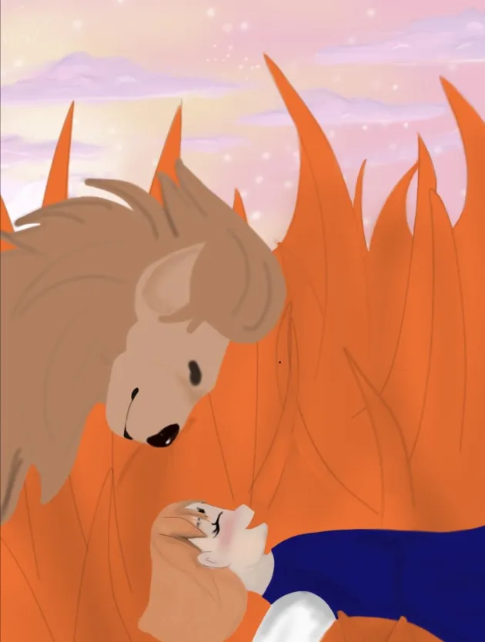

The Lion’s Bad Day
The Lion shook his long golden mane and roared again! “R-----o-----a-----r!” But Isobel wasn't afraid. She knew that inside that big angry lion was a tiny frightened pussy cat, “Are you having a bad day,” she asked, ever so politely. For the lion was very grouchy!
The lion lowered his sad eyes. He lifted his great big paw. She saw a nasty black thorn sticking out of it, “Oh! Mr. Lion, I can fix that.”
The lion lay down so Isobel could put his paw on her lap. Gently, ever so gently, she pulled the nasty thorn out, “Thank you,” said the grateful lion. He crouched down on four elbows. Then he licked Isobel's face. His tongue was as long as she was, “Come up on my back,” he said. Isobel climbed up and threw her arms around the lion's neck. They charged through the jungle. Phaedro could scarcely keep up with them.

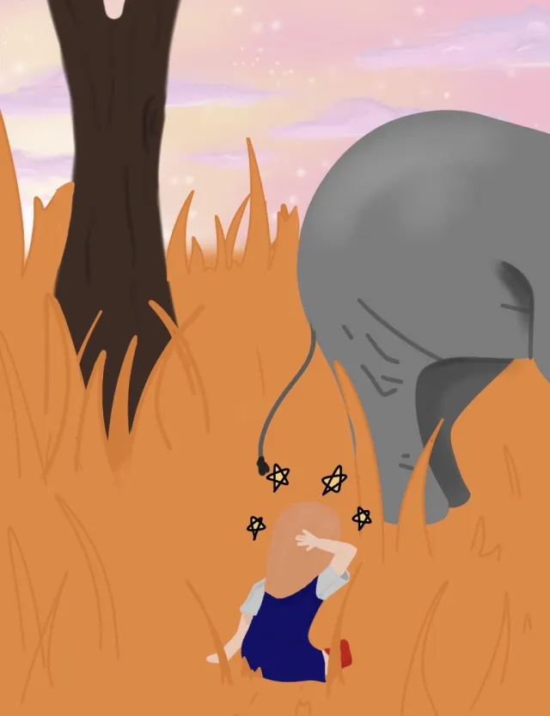

Isobel Discovers a Fawn
The lion stopped. Isobel flew over his head and tumbled head over heels into the grass. She lay there laughing, looking up at the green sun. A small black nose pushed its way through the long grass beside her. It touched her cheek, “Ooh! That's wet,” she said and screwed up her face. The nose disappeared, “Oh! Please don't go,” she cried and scrambled to her feet. On the other side of the grass, she found the loveliest of creatures.
The fawn had bandy legs. Her brown skin was covered with pretty white dots. Big angelic eyes twinkled at Isobel. And she had a large shiny black nose. The fawn was trying to catch her own shadow. Isobel helped her chase the illusive, slippery shadow. It seemed to have a life of its own and fled behind a tree.
Isobel raced after it and banged into a huge grey wall, “Ouch!” She bounced backwards and lay in the grass, “That hurt,” she declared. Then her mouth dropped open.

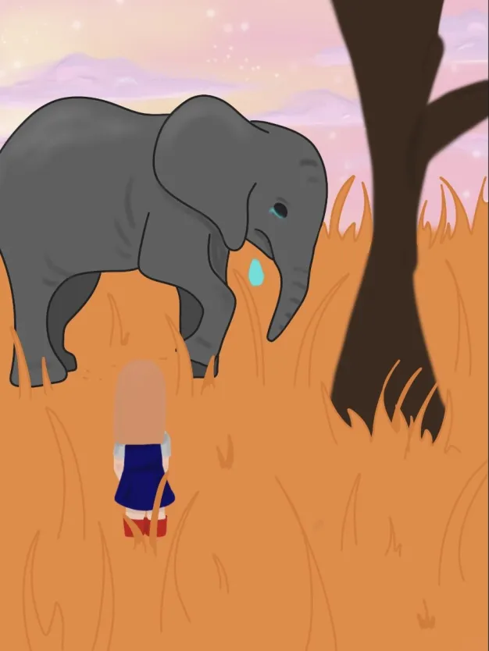

Isobel Helps an Elephant
Towering above her was an enormous elephant. He stood, gazing up at a tree. Right on the very top, a few red leaves hung. A giant tear rolled out of the elephant’s eye and plunged to the ground. Isobel just managed to slide out of the way, “You nearly drowned me,” Mr. Elephant. She shouted as loud as her little voice could go.
“Sorry!” Apologised the elephant in a squeaky, trumpety way, “I didn't see you there.”
“You must be having a bad day too!” She replied.
The elephant leaned down close to Isobel’s ear, “I’m hungry,” he told her, “I can’t reach my dinner!”
“Have you tried standing on your hind legs,” Isobel suggested.
“Yes,” said the elephant, “I’ll show you. But even on his hind legs, with his trunk fully outstretched, he was not quite tall enough to reach the leaves.
“If you hold me in your trunk,” Isobel said bravely. It was very brave of Isobel because the tree was ever so high, “I could pick the leaves for you.”
“Could you! Would you!” Exclaimed the elephant, “I would be so grateful.” With that, he curled his huge grey trunk around Isobel. Isobel wasn't afraid. She knew the elephant would not let her fall. He held onto her very tightly, “Hold on now!” Then he lifted her high into the air. Isobel dropped the red leaves into his mouth, “Thank you,” said the grateful elephant.
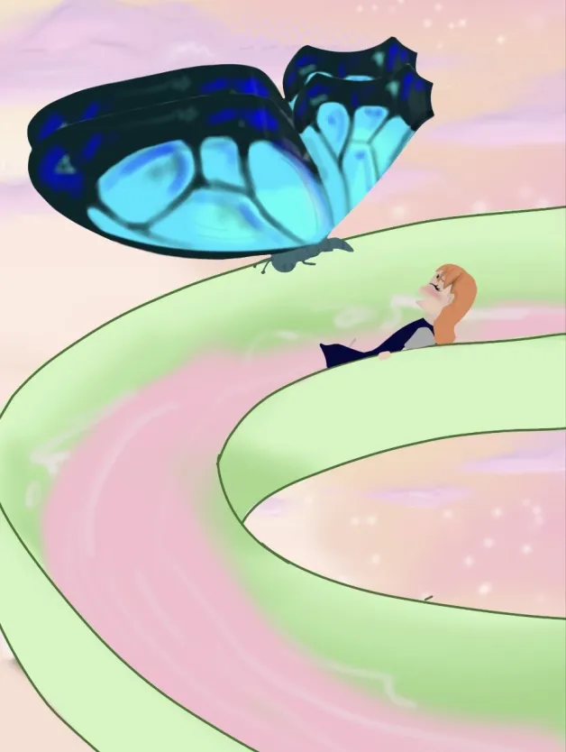

The Hydro-slide
Suddenly the huge elephant whirled round like a ballerina. He stood on one leg. Isobel held her breath. He put her carefully into a bucket that hung over an old brick wall. Then he lowered her down to ..., “A hydro-slide,” she cried excitedly, “Choice!”
Isobel stepped out of the bucket. She sat feet first, then off she zoomed. Round and round she went, laughing. Little drops of pink water danced in front of her. Isobel tried to catch them. She sped to the bottom with Phaedro following her. What a splash she made. Down she went into very deep water. She flapped her arms madly. Soon she was back on the surface, gasping for breath. Over she twisted, kicked her feet and began to swim on her back. Phaedro came and sat on her nose.

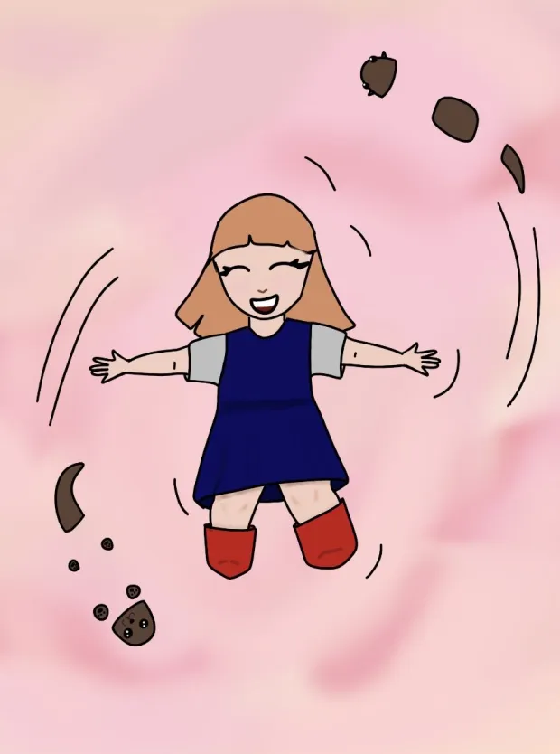

The Joyful Otters
Suddenly two small furry torpedoes whizzed in and out of her arms. They scampered between her feet, then scrambled over her head. Poor Phaedro nearly drowned. “Hey,” protested Isobel.
“We’ve come to play,” an otter’s head popped up under Isobel’s arm.
“Tag!” A second head appeared up under her other arm, “You’re it!”
Isobel went to grab them. But they had gone. The otters were far too fast and, far too good at hiding.

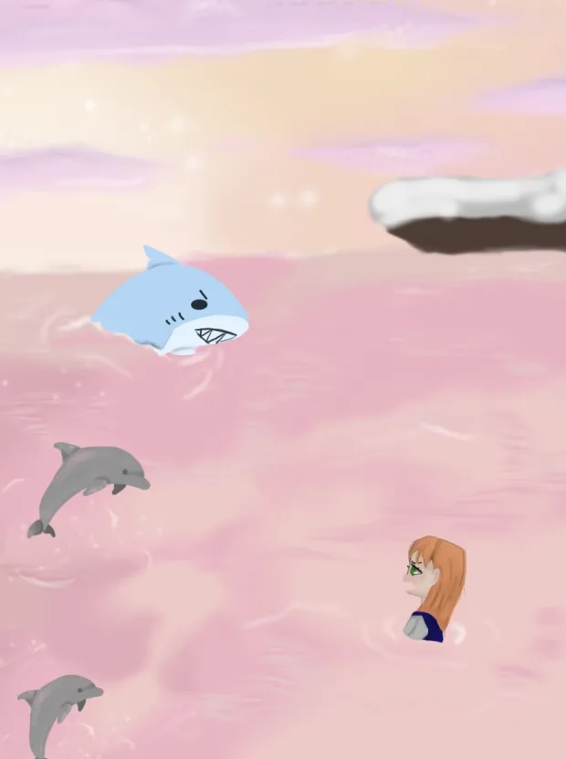

Saved by the Brave Dolphins
Exhausted, she looked around. Eyes with sharp flashy teeth and hungry drooling mouths looked back. Isobel was afraid. The eyes belonged to a school of mean looking sharks. Before she could cry for help, she heard a squeal from below.
Five dazzling dolphins came barrelling up with bubbles streaking all around their bodies. They reached Isobel, turned and faced the sharks. The mean hungry sharks kept their distance, for they were afraid of the brave dolphins. The dolphins guarded Isobel and swam with her to a small sandy beach.

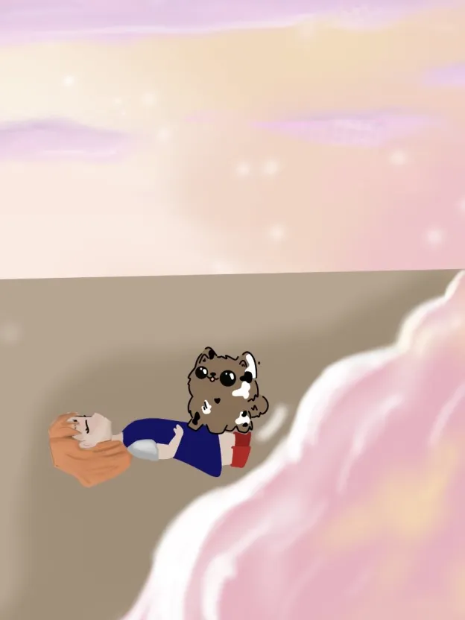

A Tiny Puppy
“You’re soaking wet!” At her feet, Isobel saw the tiniest of puppies. It was brown with black and white patches and eyes as big as saucers, “I can show you how to get dry!” The little dog shook her body furiously until all the fur stood on end. Isobel knelt down. She shook herself furiously, just like the little dog. Water sprayed out and in no time at all, she was dry.

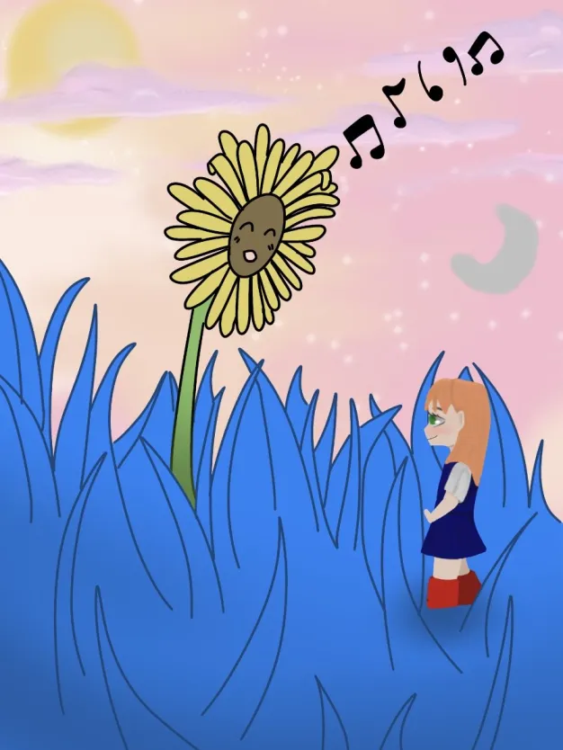

The Garden
They walked through the long grass and found themselves in a beautiful garden here the flowers were as tall as she was and they had faces and could sing. Beautiful harmonies filled the air. Above in the sky the moon and the sun lay side by side. The man in the moon was staring open mouthed at the sun and she was smiling lovingly back at him.
The puppy and Isobel took off to explore the garden. They played hide and seek behind the tall trees. Isobel stood on tip toe and eyeballed a sunflower. She lay flat on her stomach and winked at a pansy. As she smelt a rose, a bumble bee flew out. She jumped back in fright, for it nearly stung her. They danced beside a Kowhai tree with multi-coloured flowers. They danced in time with the music and the flowers of the Kowhai tree danced along with them.
Then crawled beneath a big red Pohutukawa tree. Raced a fast-running stream, jumped in a canoe and paddled under a weeping willow. The tree bent over and whispered as they went by.

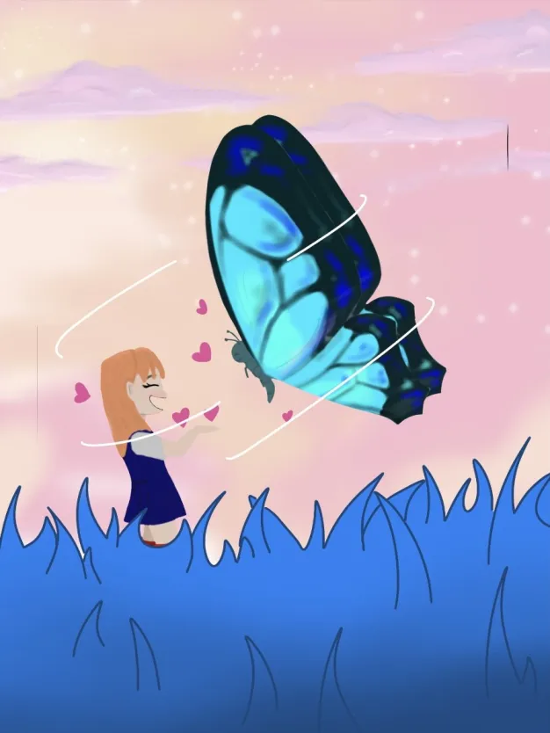

Phaedro Says Goodbye
As the sun began to set, Phaedro flew down. He came very close to Isobel’s cheek, “It is time to go,” he whispered. Phaedro fluttered his wings together and gave her a beautiful butterfly kiss. It made her feel so wonderful inside, she did not want to leave. Then Phaedro spoke to her heart, “Whenever you feel alone or sad or unhappy, I will come to you. We’ll always be together. And perhaps another day,” he whispered, “We’ll have another adventure.”
“I would like that,” said Isobel. Phaedro was standing on the palm of her hand. His feet tickled as they kneaded her. She patted his head careful not to break his antennae.

Going Home
They were standing beside a tall garden gate, “Go through,” whispered Phaedro, “You must go home now.” Isobel opened the gate. She was bathed in the most magnificent white light. Although it was very bright, like the sun, Isobel was able to look at it.
When she walked out of the light, she found things were back to normal. The grass was green. The sky was blue. All the leaves in the trees were green. And the sun, once again, was a yellow circle, “Wow!” Said Isobel, “that was choice!”

THE END

© 1998 Kiwi Opa, CC-BY-NC

