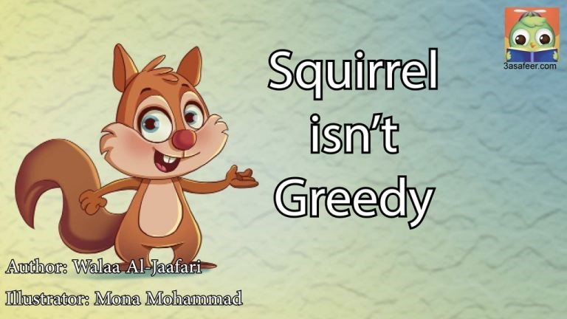
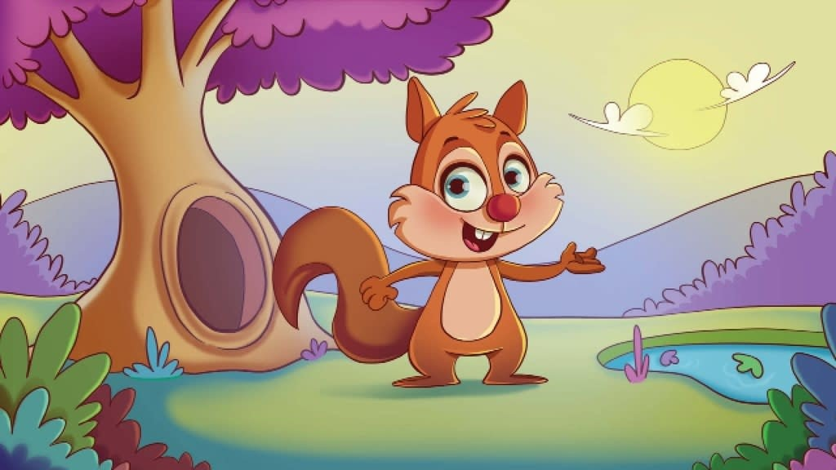
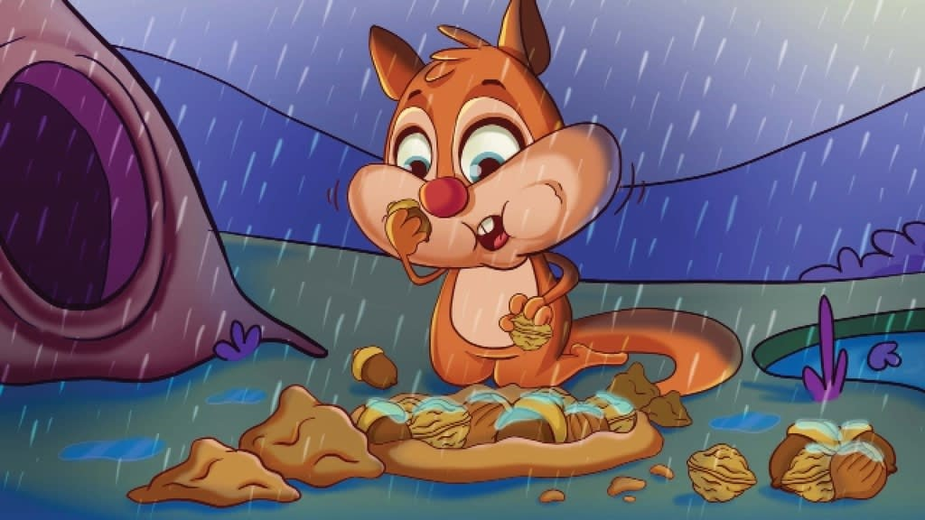
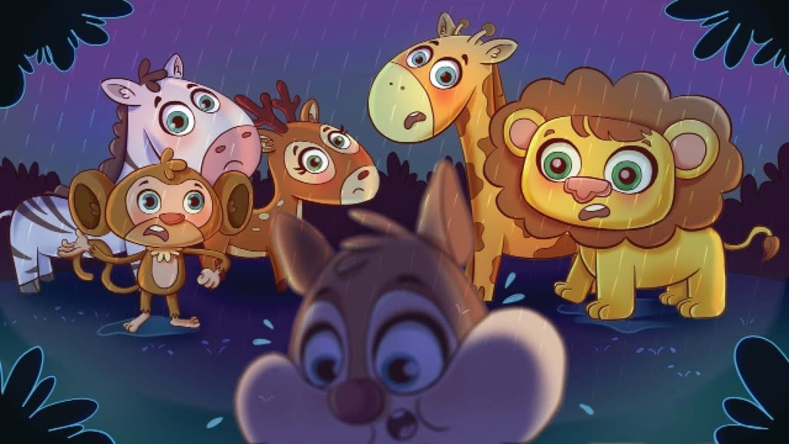
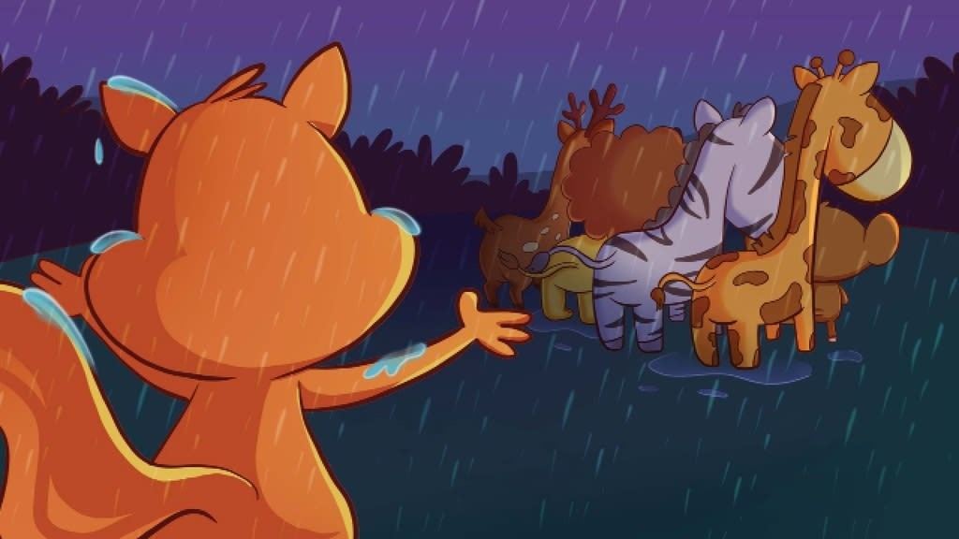
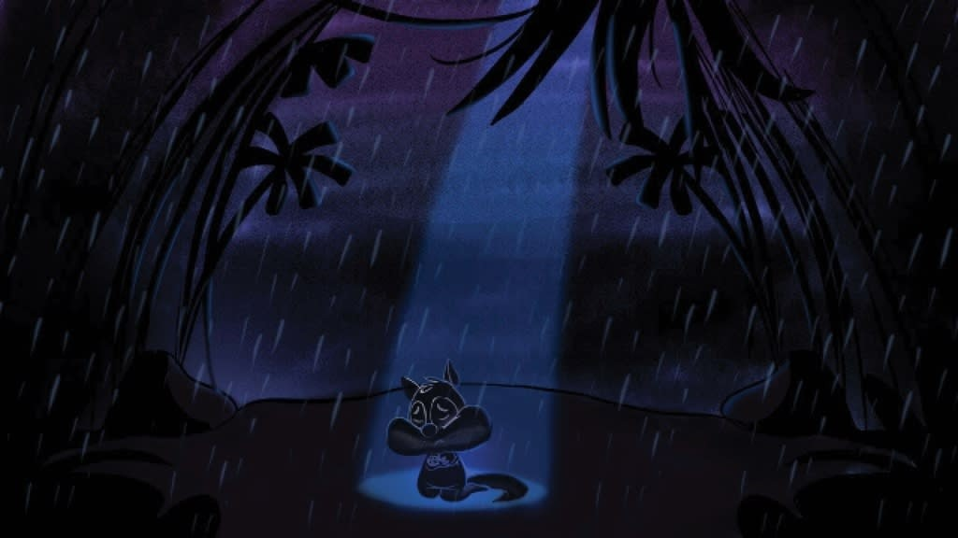
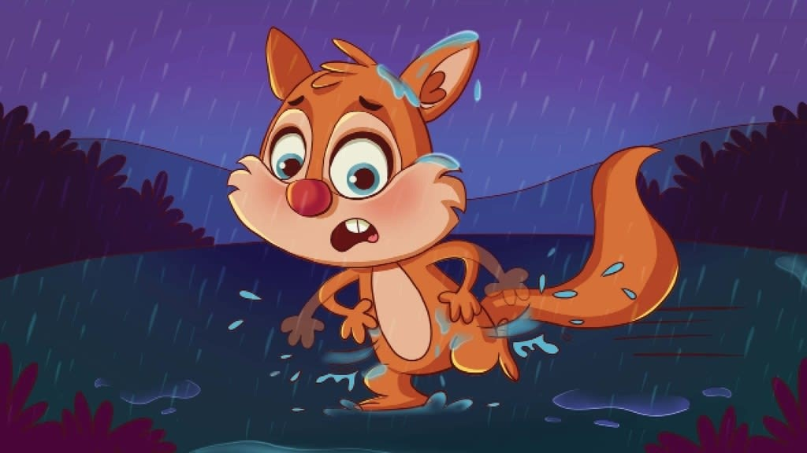
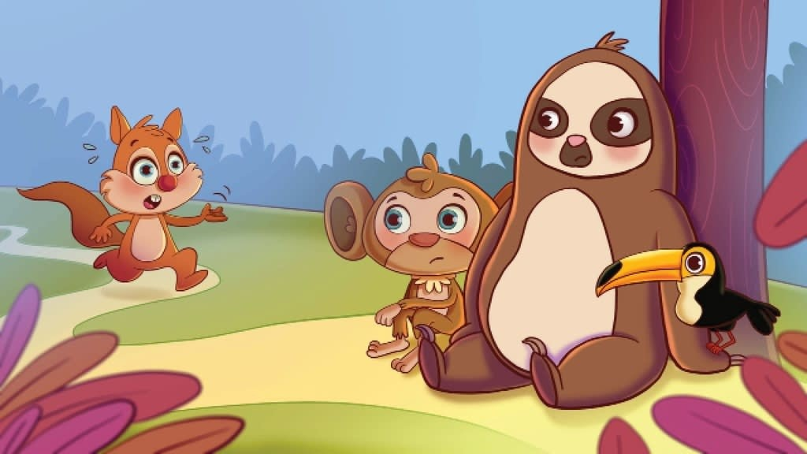
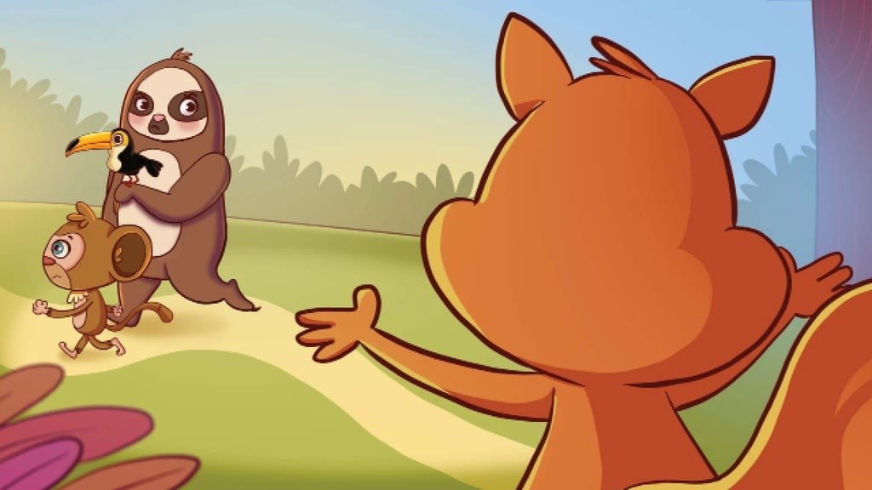
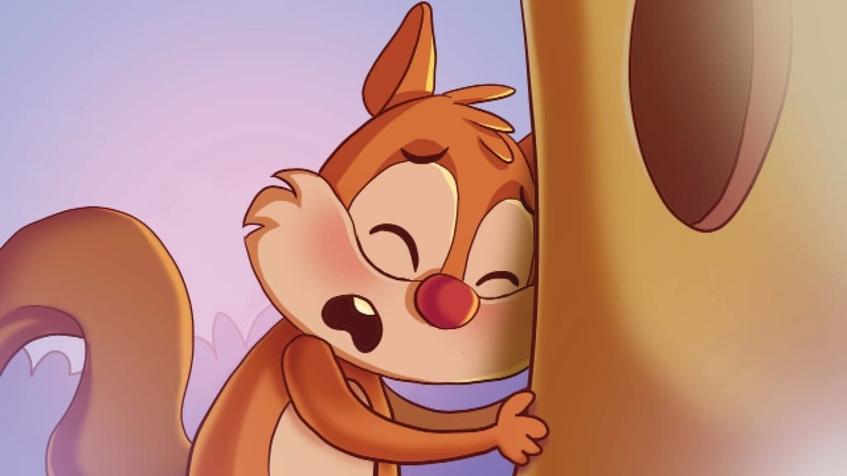
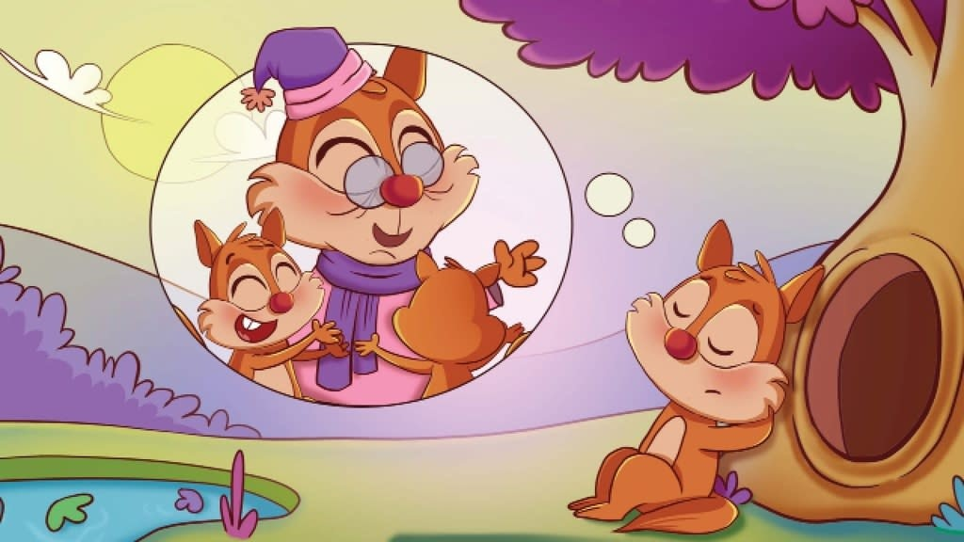
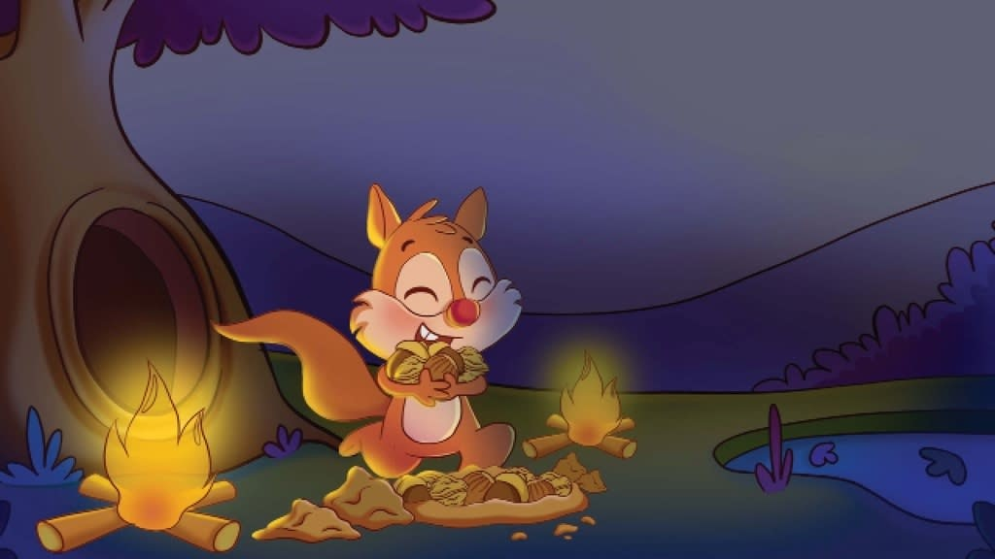
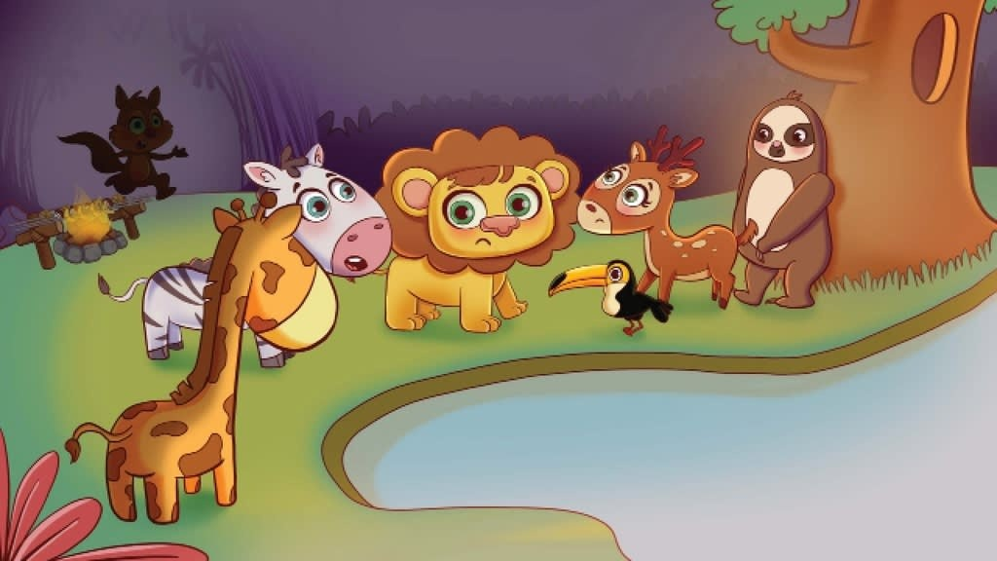
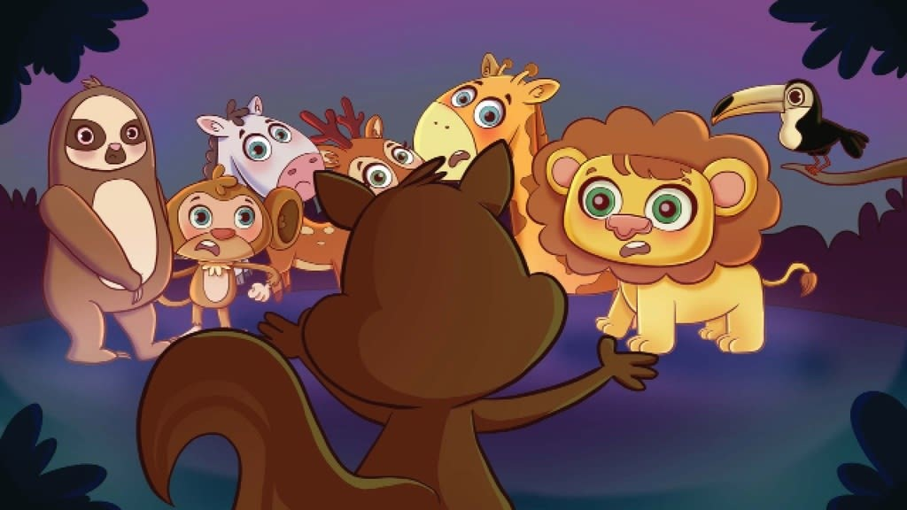
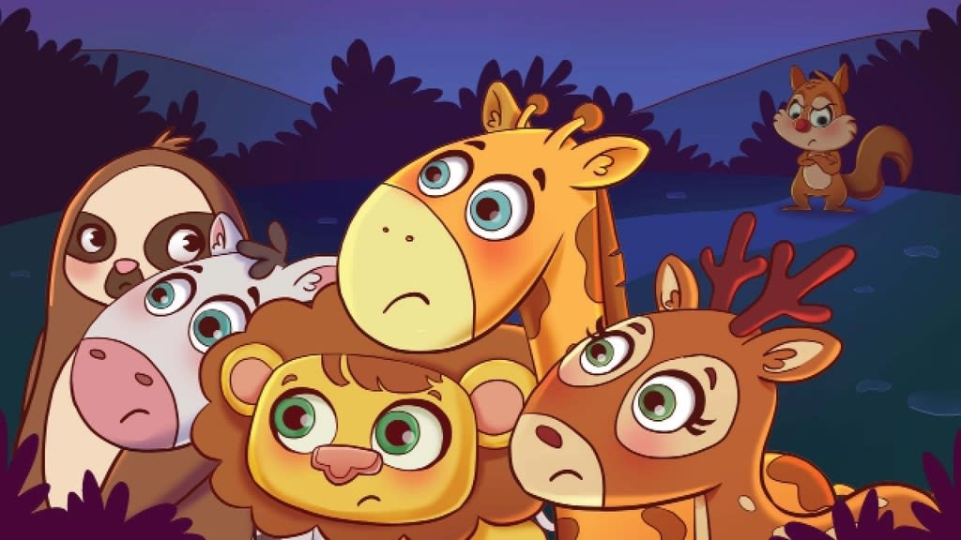
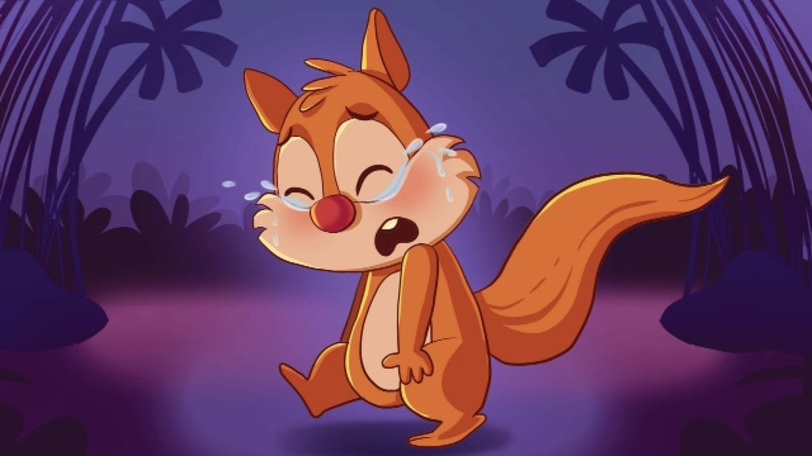
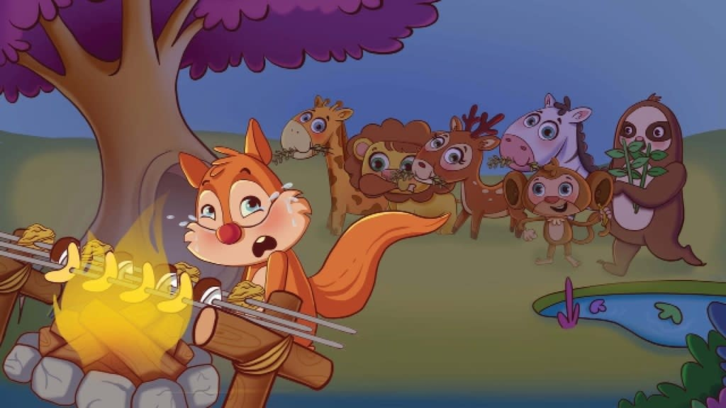
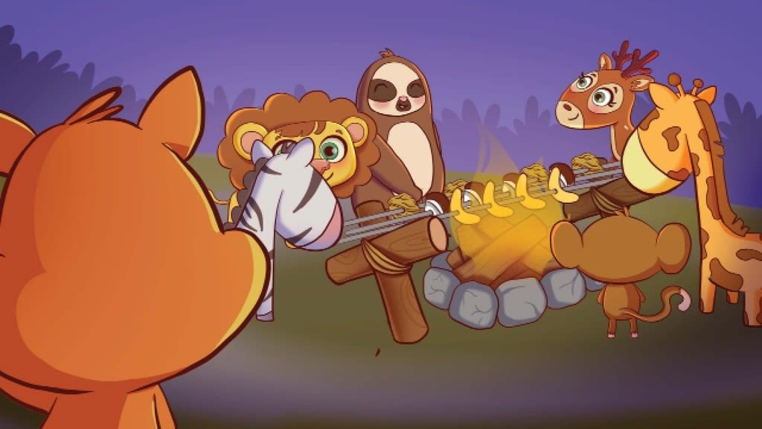
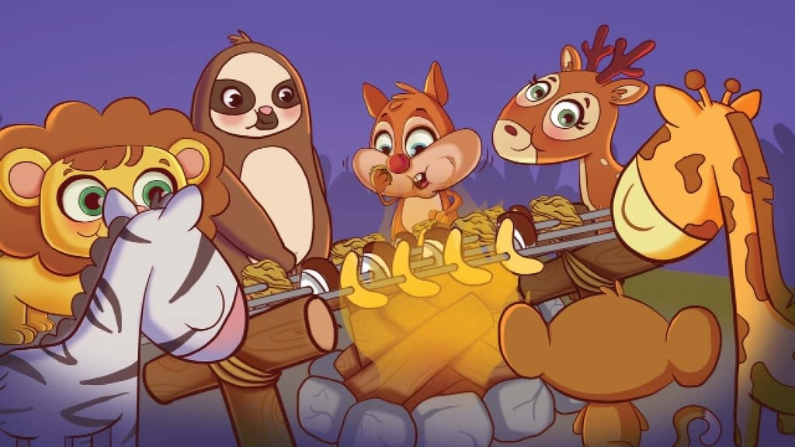
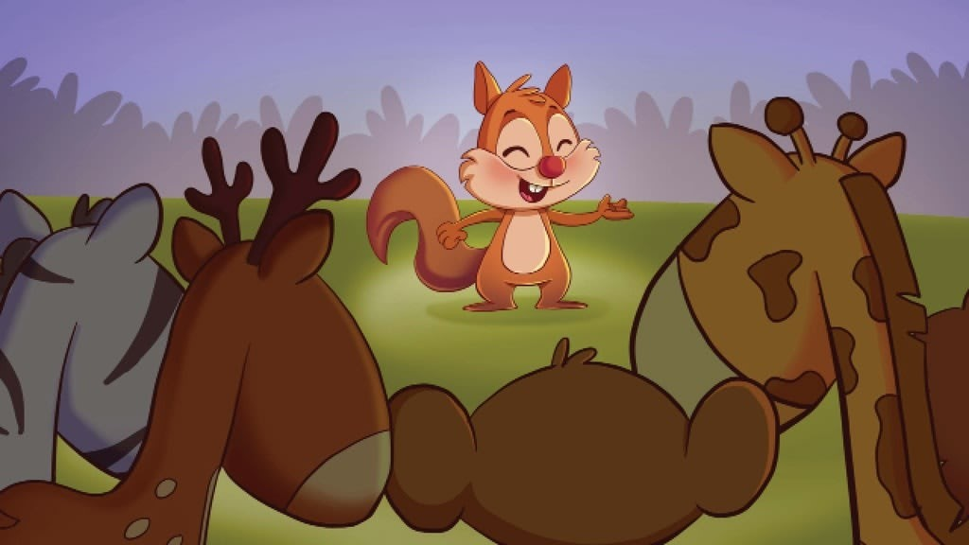
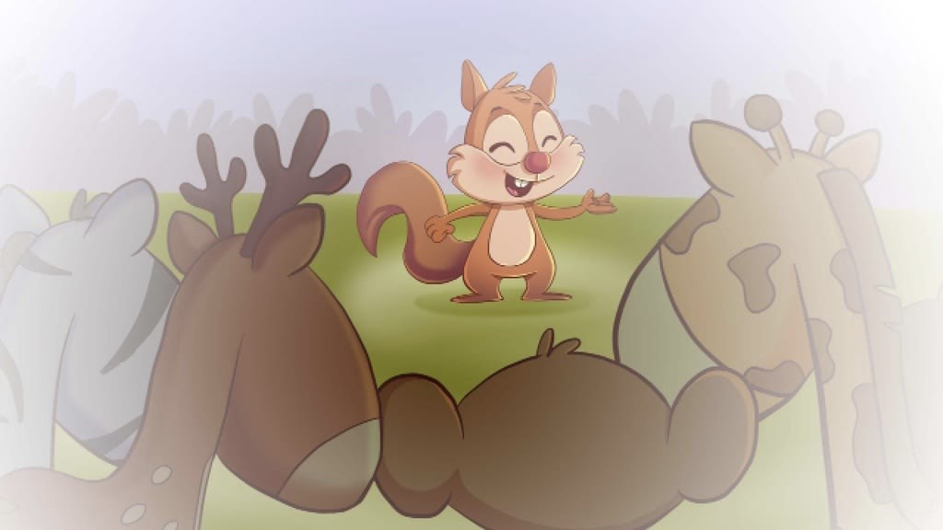

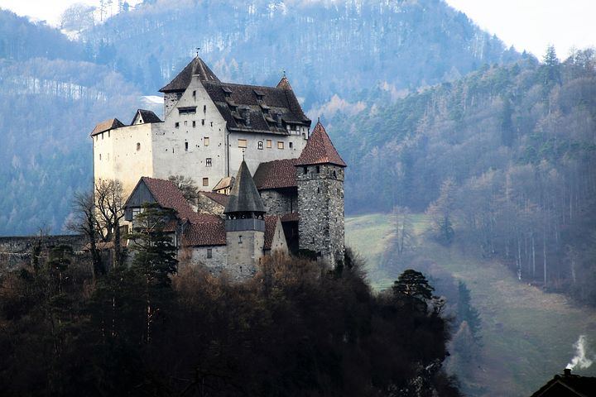

Why settle with ordinary when you can
write your
own fairytale?
www.freekidsbooks.org
Author Walaa Al-Jaafari, Illustrator Mona Mohammad
Copyright
www.3aSafeer.com
CC-BY-NC

Copyright © Asafeer Education Technologies FZ LLC, 2018 http://creativecommons.org/licenses/by-nc-sa/4.0/
You may not use this work for commercial purposes. You may adapt and add to this work, but you may distribute the resulting work only under the same or similar license to this one. You must keep the copyright and credits for authors, illustrators, etc.

Squirrel finally found a beautiful new home in the rainforest. As soon as he settled in, he said, “Wow! I just love my new home. I love the rain, the green grass, and I even love the swamps.”

When it rained, squirrel took some acorns and hazelnuts and stored them in a hole. Then he gobbled a few others up.

The animals looked at him and whispered, “That new squirrel seems very greedy. He’ll end up eating everything in the rainforest. Do you think he’ll stick around?”

Squirrel looked at them and wondered, “Am I really greedy?” While he was thinking, the animals silently turned and walked away.

Squirrel felt sad and cold, just like an ice cube that was melting in the rain.

He shook the raindrops from his body and his tail and said,
“I’ll just have to explain.”

Squirrel ran and ran until he found the toucan, the monkey, and the sloth.
He walked up to them and said, "Hello, my friends. Did you know that squirrels collect lots of nuts and...”

Before he could finish, the animals just looked at him in disdain and left. To squirrel, the green rainforest was no longer a beautiful, happy place. It now felt dreary and sad. He said, “I can’t stay here like this. I want to explain myself, but, they have to give me a chance.”

He leaned against the bark of a tree and thought, “They’ll always just think I’m greedy.”
Then he shouted, “It’s not true and it’s not fair!” Then he decisively said, “I don’t like my new house anymore. I’m leaving right now!”

Before he left, he closed his eyes for a moment to rest and began to think of all the happy memories he had of his friends coming to play as Grandma’s sweet voice would say, “Winter parties are so much fun for everyone!”

He opened eyes and jumped up, saying,
“Maybe the animals need one of those winter parties,”
He took some nuts from where he had stored them and lit a fire to start a nut barbeque.
Down by the river, the animals whispered, “Look at him. He’s making himself a huge feast.”
“I’m sure he’ll take all the food in the forest! Let’s go tell him - either he stops taking so much or he has to go.”
Suddenly a strange shadow appeared and all the animals trembled with fear.

But it was only squirrel. He said, “Come, my friends. I’m having a barbeque just for you. It will be so much fun.”

The animals were surprised. They didn’t say a word .

Then they left.

Squirrel slowly walked home, his footsteps heavy with sadness. He lowered his head and a tears rolled down his cheeks. He wondered, “Why did they leave? Why do they insist that I ’ m greedy?

After a while, the animals came back carrying fruits and leaves and said,
“A fruit barbeque is just what we need!”

Squirrel couldn’t believe his eyes. The animals all sat around him and grilled coconut and cocoa kababs and even bananas and pineapples.
Delicious!

Everyone talked and ate.

Then squirrel said, “What I’ve been trying to say is that I might seem greedy, but I’m only storing food for winter.”
“Sometimes I also store it tucked in my cheeks when I’m hungry.” The animals looked at each other and said,
“Oh! We’re sorry! Now we understand.”
The all chorused
“Next time, we’ll just let our new friends explain!”

-The End-

