So long,
Thanks!!
For all the fish :-)

Odd One Out
od wun owt
Danielle Bruckert
FREE KIDS
BOOKS

Odd One Out / od wun owt
Published by Red Sky Ventures
Created by Free Kids Books October © 2019

This work is licensed under the
Creative Commons Attribution-ShareAlike License, CC-BY-SA-NC
http://creativecommons.org/licenses/by-nc/4.0/

This text is free for non-commercial distribution and use, including reposting on non-profit and educational websites.

No part of this text may be reproduced for resale
without express permission of the author.

Any use of this material must be attributed to:
Free Kids Books – http://www.freekidsbooks.org

Contact the Creator
danielle@redskyventures.org

Translated into Pinglish by Paul Gough
pinglish bI porl gof
https://thepinglishproject.com

More books like this one are available at

http://www.freekidsbooks.org

Psychedelic seal was different to all the other seals. The other seals were all brown. They blended in on the sandy shores and in the ocean.

Psychedelic seal didn't blend anywhere.

sIcedelic sEl woz diferent too orl the uther sElz.
the uther sElz wur orl brown.
thA blended in on the sandE shorz and in the Oshen.
sIcedelic sEl didnt blend enEwer.
Psychedelic seal's mum tried to protect him from the big bad world out there – she worried about two problems, not only did the other seal pups tease and laugh at poor Psychedelic seal, but she worried that he was a big target for a predator.

sIcedelic sElz mum trId too prOtect him from the big bad wurld owt ther shE wurEd abowt too problems not OnlE did the uther sEl pups tEz and laf at pooer sIcedelic sEl but shE wurEd that hE woz a big target for a predator.

But Psychedelic's father was more practical and told Mama seal – we have to make Psychedelic strong: Physically – so he can fight off predators, and emotionally so he can brush off the cruel taunts he might get from being different.

but sIcedelics father woz mor practical and tOld mama sEl wE hav too mAc sIcedelic strong fisicalE sO hE can fght of predatorz and emOshunalE sO hE can brush of the crooel tornts hE mIt get from bEing diferent.

While kids can be cruel and Mama seal considered keeping Psychedelic in home school to protect him, Papa seal said – no. If we bring him up to be proud of his differences, and teach him to be physically and emotionally strong – one day it will pay off. Cruel taunts don't always stop when kids grow up, Papa seal reminded Mama seal.

Mama seal realised wrapping Psychedelic seal up in cotton wool wasn't good for anyone, so she agreed to Papa seal's plans.

The family went about a program of physical and emotional training that in fact helped them all become better seals.
wIl cids can bE crooel and mama sEl considerd cEping sIcedelic in hOm scool too prOtect him papa sEl sed nO.

if wE bring him up too bE prowd ov hiz diferenses and tEch him too bE fisicalE and pAj for emOshunalE strong wun dA it wil pA of.

crooel tornts dOnt olwAz stop wen cids grO up papa sEl rEmInded mama sEl.

mama sEl rEalIzd raping sIcedelic sEl up in coton woul woznt goud for enEwun sO shE agrEd too papa sElz planz.

the familE went abowt a prOgram ov fisical and emOshunal trAning that in fact helpd them orl bEcum beter sElz.

Physically they swam long distances, dove deep in the ocean regularly, and Papa and Psychedelic practiced sparring until he got very good.

fisicalE thA swam long distanses duv dEp in the Oshen regUlarlE and papa and sIcedelic practisd sparing until hE got verE goud.

Emotionally and cognitively they practised meditating, debating, and reading philosophy texts from the ancients.

The family also engaged in long discussions around the dinner table about seal rights, environmental concerns, and dealing with discrimination among other important topics.
emOshunalE and cognitivlE thA practisd meditAting debAting and rEding filosofE texts from the Anshents.

the familE olsO engAjd in long discushuns arownd the diner tAbl abowt sEl rIts envIronmental consurns and dEling with discriminAshun amung uther important topics.

Besides continual physical and emotional strength, Mama seal and Papa seal made sure that Psychedelic knew that his differences made him special and that he shouldn't be afraid of them. If others couldn't see that, the problem was with them, not him. He should be happy in his own skin – psychedelic as it may be, and not worry about what others think or say. He always remembered this.

bEsIdz continUal fisical and emOshunal strenth mama sEl and papa sEl mAd shooer that sIcedelic nU that hiz diferenses mAd him speshal and that hE shoudnt bE afrAd ov them.

if utherz coudnt sE that the problem woz with them not him.

hE shoud bE hapE in hiz On scin sIcedelic az it mA bE and not wurE abowt wot utherz thinc or sA. hE olwAz rememberd this.
As time went by Psychedelic grew into a dashing, competent young seal, and while he still stood out like a sore thumb, and he was still sometimes the butt of the jokes, his emotional and physical maturity allowed him to give back as good as he got. Psychedelic seal would always be different, but he had learned from his father and mother that differences are what make us special and he could in time be stronger for his differences.

az tIm went bI sIcedelic groo intoo a dashing competent yung sEl and wIl hE stil stoud owt lIc a sor thum and hE woz stil sumtImz the but ov the jOcs hiz emOshunal and fisical matUritE alowd him too giv bac az goud az hE got.

sIcedelic sEl woud olwAz bE diferent but hE had lurnd from hiz father and muther that diferenses ar wot mAc us speshal and hE coud in tIm bE stronger for hiz diferenses.
Over time time the seals noticed that their their resources were getting fewer and farther between. It was apparent that the sea vessels were overfishing the resources. There were research vessels also patrolling, but the seals didn't know how to reach them as they were very far out and it seemed they couldn't see the colony or what the fishing vessels were doing. Suddenly Psychedelic seal had an epiphany. This was HIS time to shine :-).

Over tIm tIm the sElz nOtisd that ther ther rEsorses wur geting fUer and farther bEtwEn.

it woz aparent that the sE vesels wur overfishing the rEsorses.

ther wur reserch vesels olsO patrOling but the sElz didnt nO how too rEch them az thA wur verE far owt and it sEmd thA coudnt sE the colonE or wot the fishing vesels wur dooing.

sudenlE sIcedelic sEl had an epifanE.

this woz hiz tIm too shIn.
Digging deep down and sourcing everything he had learned during his youth – improving his physical and emotional well being, Psychedelic seal swam as far and as close as he could to the research vessels. When he got out to the vessels he sang out in his very best song. Because of his bright colours and sweet voice, the research vessels took notice immediately. They were intrigued colour and clear song and wanted to study the colony because of this.

diging dEp down and sorsing everEthing hE pAj nIn had lurnd dUring hiz Uth improoving hiz fisical and emOshunal wel bEing sIcedelic sEl swam az far and az clOz az hE coud too the reserch vesels.

wen hE got owt too the vesels hE sang owt in hiz verE best song.

bEcoz ov hiz brIt culorz and swEt voys the reserch vesels touc nOtis imEdEAtlE.

thA wur intrEgd culor and clEar song and wonted too studE the colonE bEcoz ov this.
Psychedelic seal went back to the seal colony not knowing if what he did worked or not.

Low and behold, shortly after, smaller research vehicles started coming in closer to the coast – The researchers had seen Psychedelic seal and they sent smaller vehicles to investigate. Soon the researchers realised the troubles the seals were facing from the overfishing and they began campaigning to the authorities to limit the quotas for fishing in the area. The researchers, after more campaigning, established a special protected area around Psychedelic seal's colony and thereafter the colony was for ever safe. The seals rejoiced and praised Psychedelic seal as a hero responsible for their means of continued survival.

sIcedelic sEl went bac too the sEl colonE not nOwing if wot hE did wurcd or not.

lO and behOld shortlE after smorler reserch vEhiclz started coming in clOser too the cOst the resercherz had sEn sIcedelic sEl and thA sent smorler vEhiclz too investigAt.

soon the resercherz rEalIzd the trublz the sElz wur fAsing from the overfishing and thA bEgan campAning too the orthoritEz too limit the qOters for fishing in the erEa.

the resercherz after mor campAning establishd a speshal prOtected erEa arownd sIcedelic sElz colonE and therafter the colonE woz for ever sAf.

the sElz rEjoysd and prAzd sIcedelic sEl az a hErO responsibl for ther mEnz ov continUd survIval.
After the colony was protected, Psychedelic seal began promoting anti-discrimination to schools and communities. The colony elders heard his message and promised to develop programmes for schools to teach children to celebrate diversity and not to discriminate against those who might be different. Going forward as generations learned better behaviours, gradually the younger generation no longer felt the pain of being ostracised for being different.
after the colonE woz prOtected sIcedelic sEl bEgan prOmOting antE discriminAshun too scoolz and comUnitEz.

So long,
Thanks!!
For all the fish :-)

the colonE elderz hEerd hiz

pAj eleven
mesaj and promisd too dEvelOp programz for scoolz too tEch children too selebrAt dIversitE and not too discriminAt agAnst thOz hoo mIt bE diferent.

gOing forword az jenerAshuns lurnd beter bEhAvyorz gradUalE the yunger jenurAshun nO longer felt the pAn ov bEing ostrasIzd for bEing diferent.

…..sO long thancs. for orl the fish.
- THE END –

This is a work of fiction.
Any resemblance to
a person, animal, or stuffy
(particularly someone in the picture below)
is entirely coincidental.

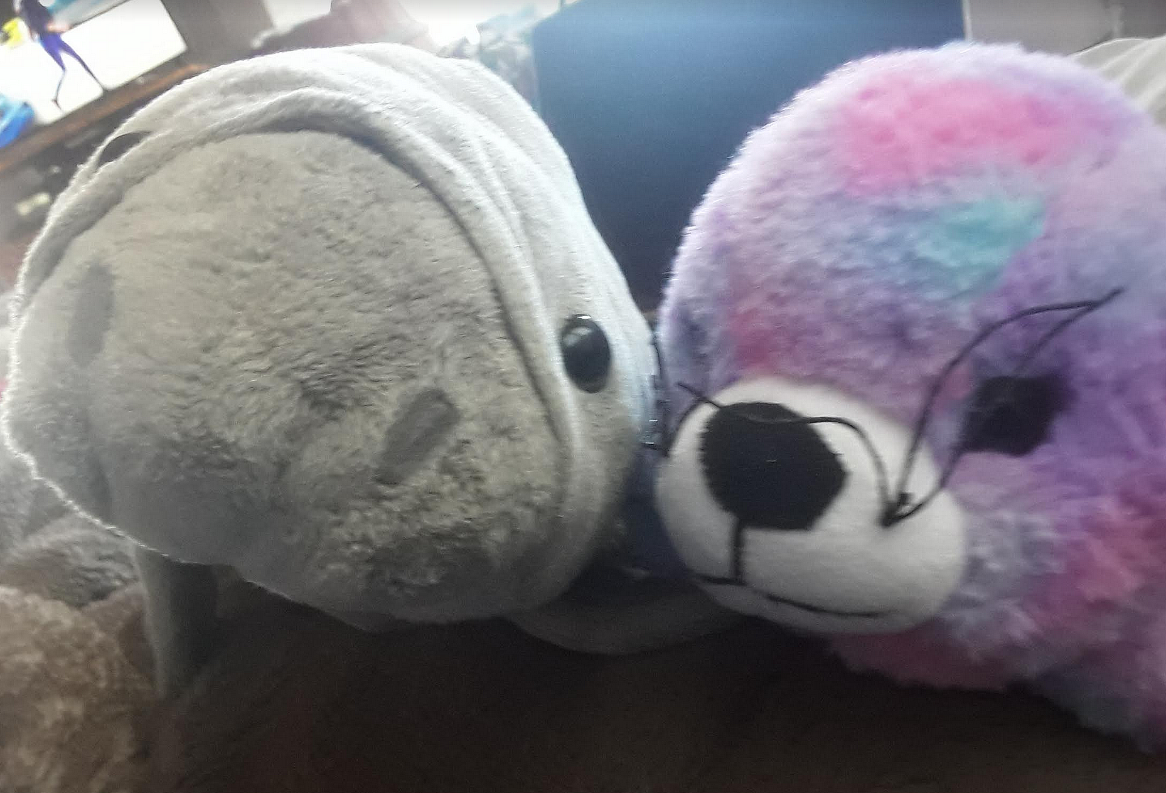

If you want to see more books in pinglish check out https://thepinglishproject.com/
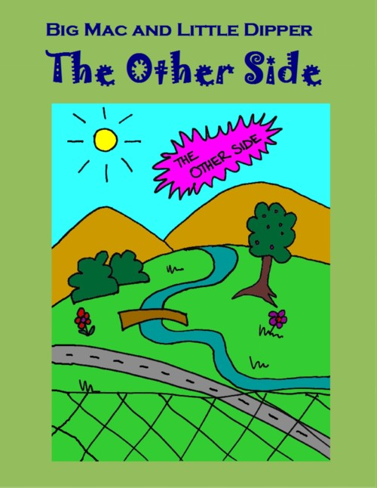
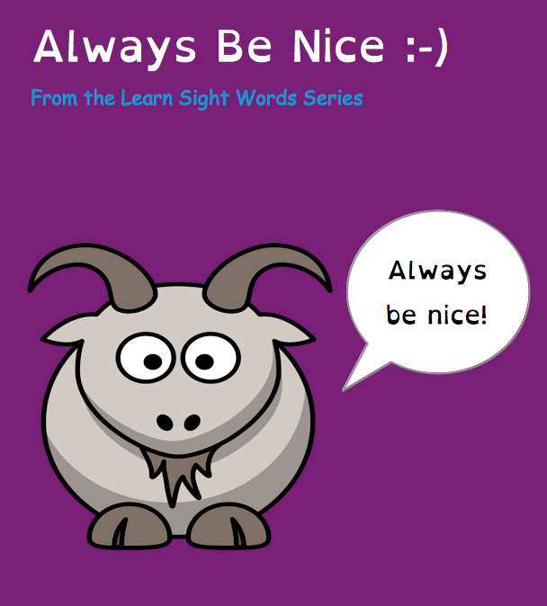
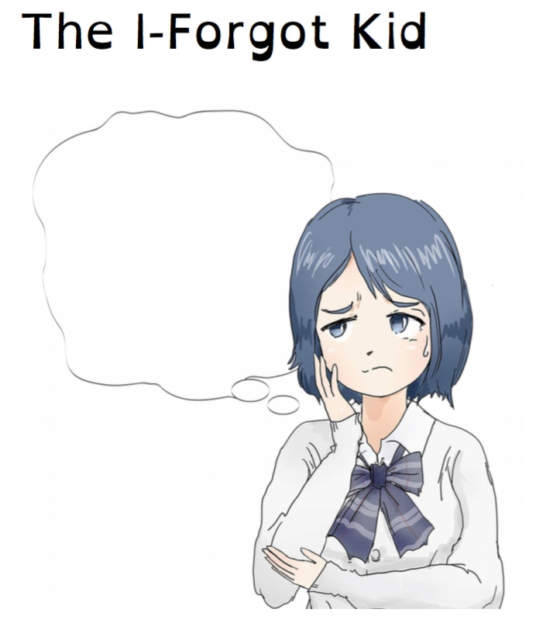
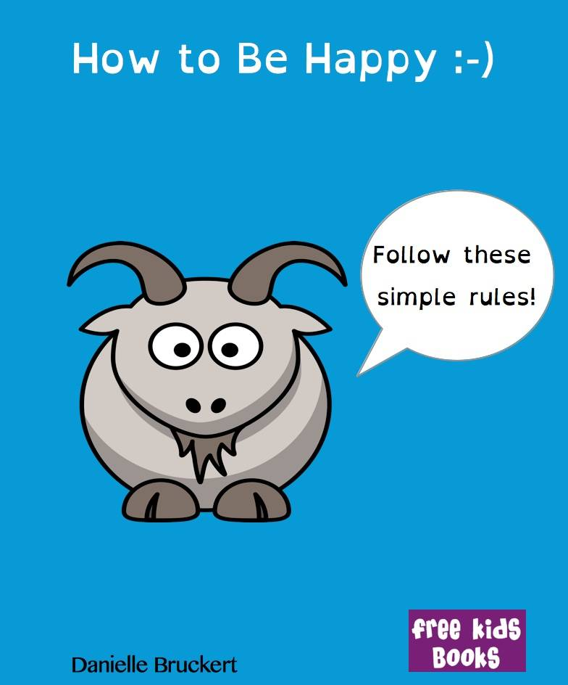
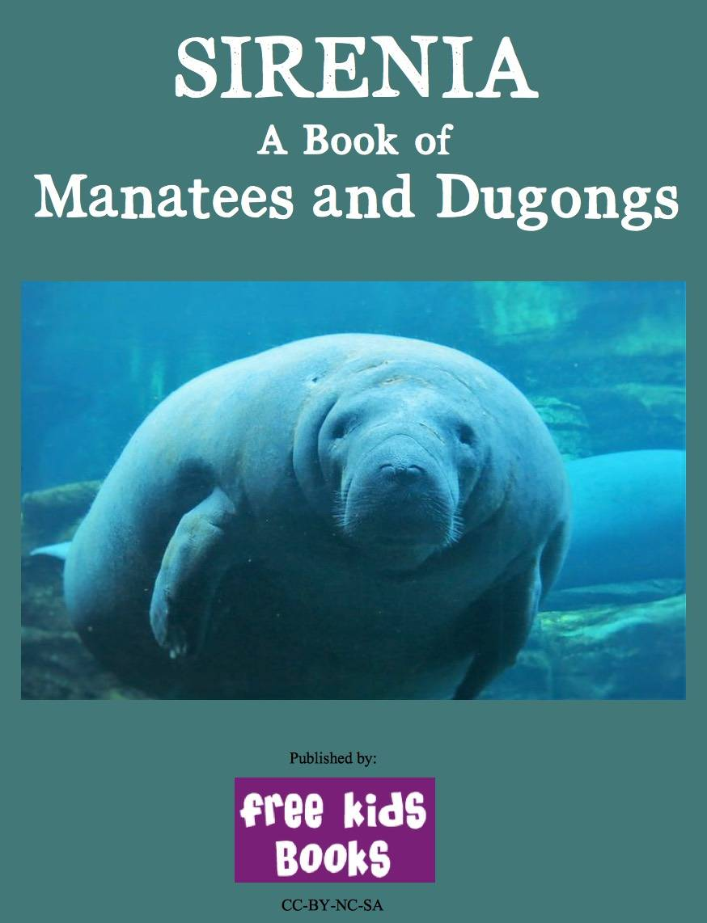
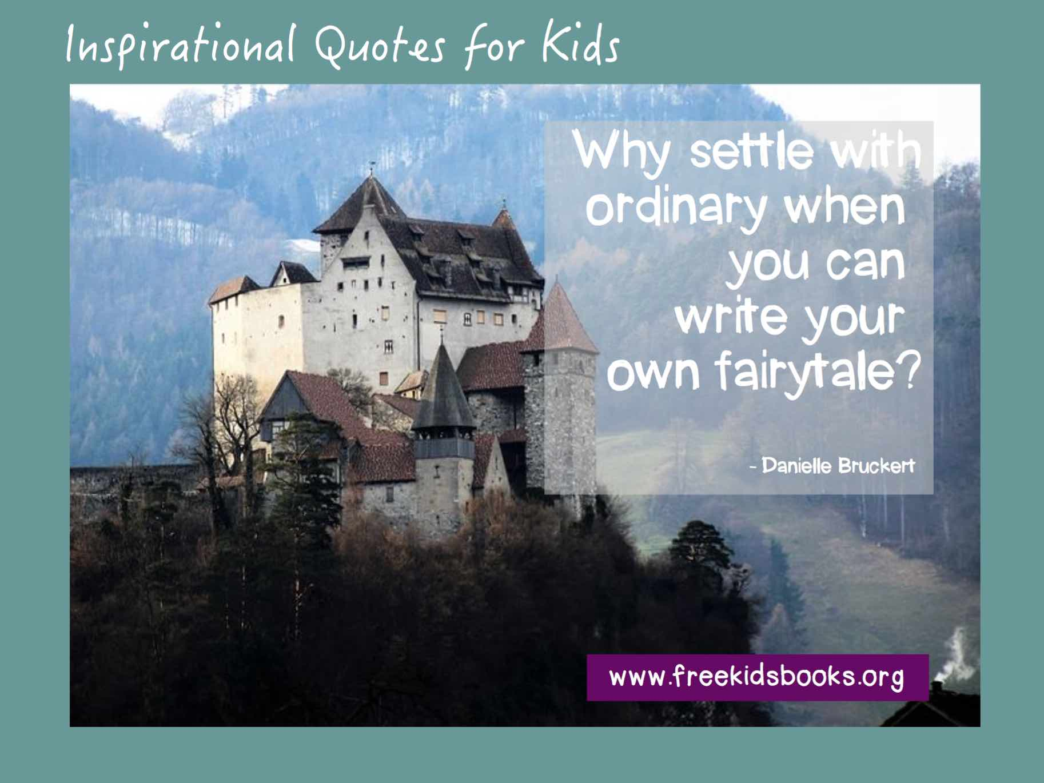
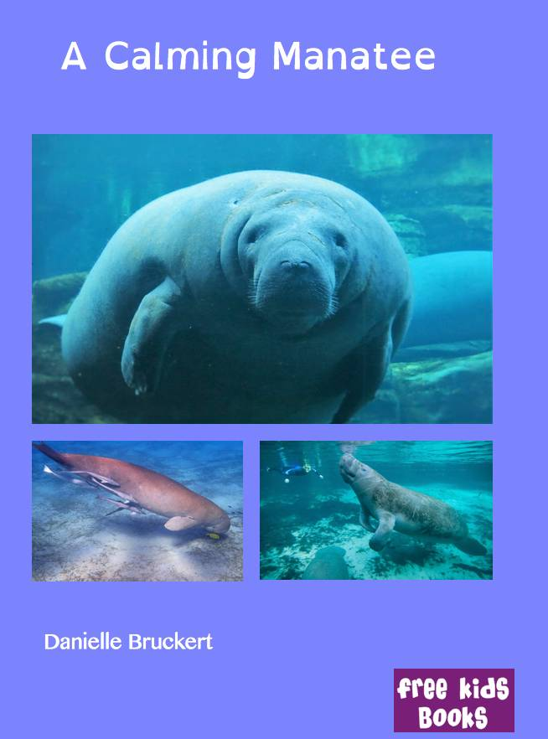
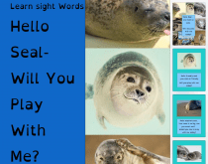
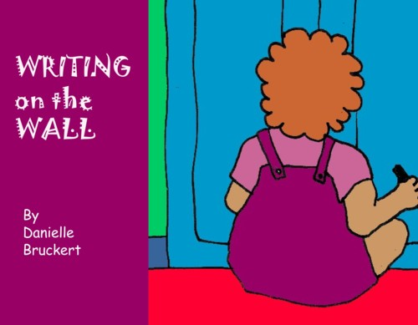
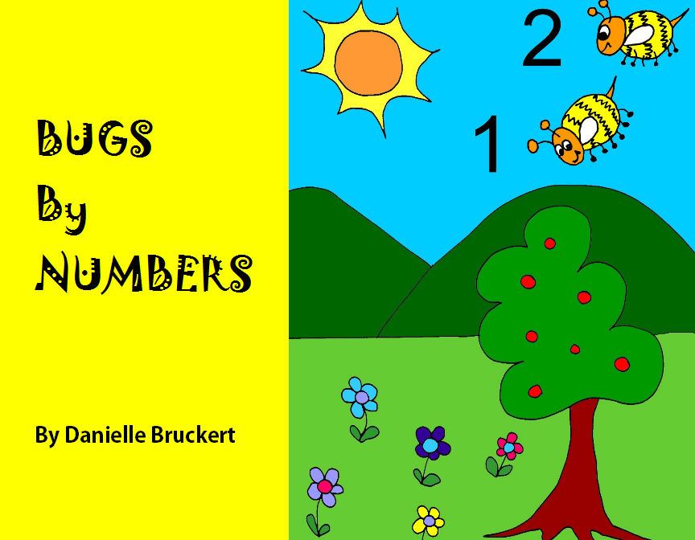
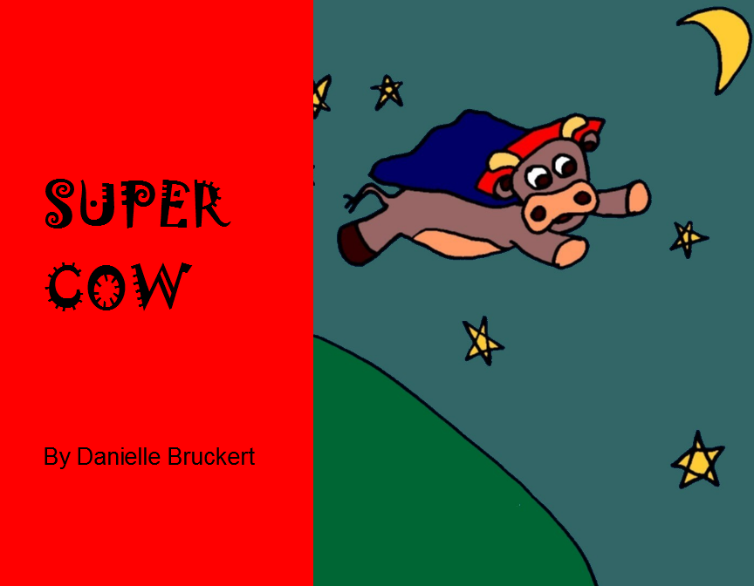

``
MORE BOOKS!
Other books available from the author:
https://freekidsbooks.org/author/danielle-bruckert/

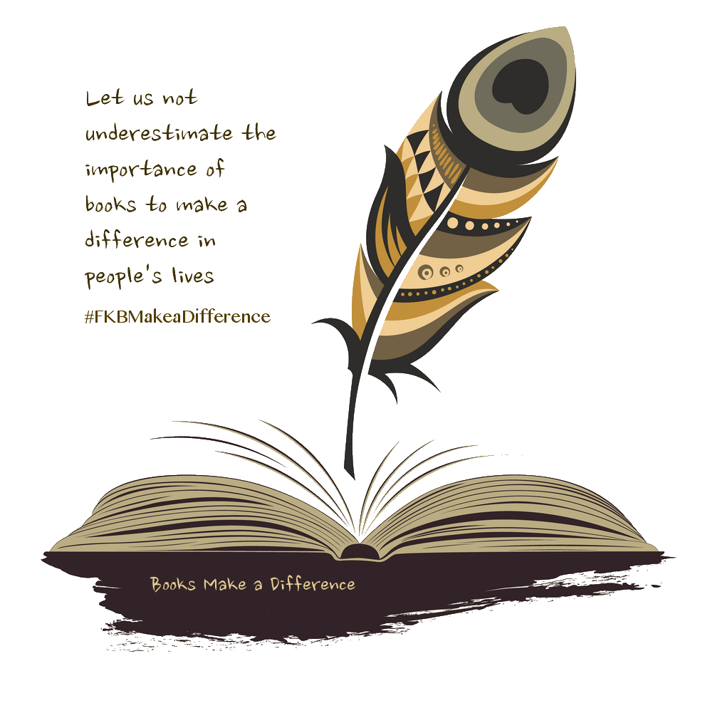


Legal Note:
This book is in CREATIVE COMMONS - Awesome!! That means you can share, reuse it, and in some cases republish it, but only in accordance with the terms of the applicable license (not all CCs are equal!), attribution must be provided, and any resulting work must be released in the same manner. Please reach out and contact us if you want more information: https://www.freekidsbooks.org/about
This page is added for identification purposes, any transmittal of this eBook version must leave this page intact.
Looking for more books like this one?https://www.freekidsbooks.org
Free Kids Books
Make a Difference
OER Resources - Books For A Cause
This eBook is part of the FKB Make a Difference Project:
https://www.freekidsbooks.org/makeadifference

