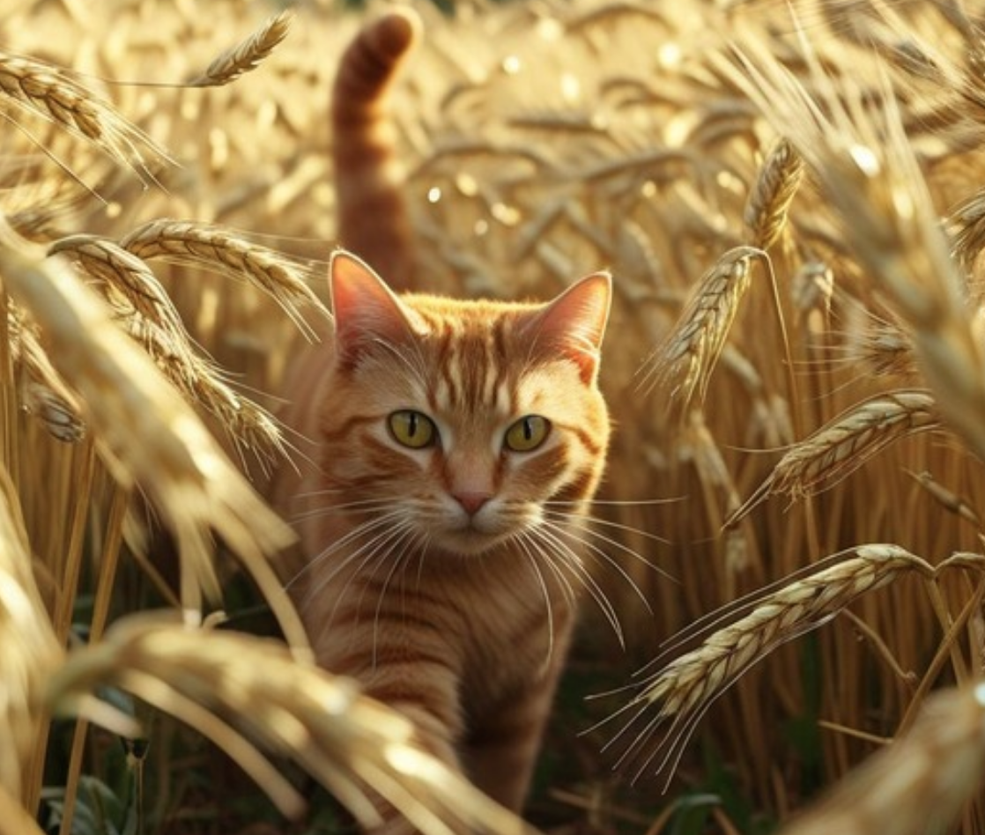
THE CAT, THE MOUSE, THE OWL, AND THE LIZARD

From Hindu Tales from the Sanskrit
For Children

Translated by S. M. Mitra
Adapted by Mrs. Arthur Bell

THE CAT, THE MOUSE, THE OWL, AND THE LIZARD

From Hindu Tales from the Sanskrit
For Children

Translated by S. M. Mitra
Adapted by Mrs. Arthur Bell

This Edition by Free Kids Books
This book is in the Public Domain

For more information:
danielle@redskyventures.org



INTRODUCTORY NOTE.
Thanks to Mr. S. M. Mitra, the well-known Hindu psychologist and politician, who has done so much to draw more closely together the land of his birth and that of his adoption, I am able to bring within reach of English children a number of typical Hindu Tales, translated by him from the Sanskrit, some of them culled from the ancient classics of India, others from widely separated sources. The latter have hitherto been quite inaccessible to western students, as they are not yet embodied in literature, but have been transmitted orally from generation to generation for many centuries.
These tales are not only of a kind to enchain the attention of children. They also illustrate well the close affinity between the two chief branches of the great Aryan race, and are of considerable ethical value, reflecting, as they do, the philosophy of self-realisation which lies at the root of Hindu culture. They have been used from time immemorial by the best teachers of India as a means of building up the personalities of the young and maintaining the efficiency of the adult. They serve in fact as text-books of the unique system of Mind-Training which has been in use in India from remote Vedic times, the root principle of which is as simple as it is effective.
Hindu children become familiar at their mothers’ knees with these stories, and are trained to answer questions on them, subtly chosen to suit their ages and call into action their mental faculties. Appealing to them as an amusing game, in which they vie with each other in trying to solve the problems presented for their consideration, the boys and girls, who are educated together till they are ten or twelve years old, early learn to concentrate their attention; whilst the simultaneous development of all their powers is encouraged and they are, imperceptibly to themselves led to control their thoughts and emotions from within, instead of having to obey orders which they do not understand from without. They realize indeed, whilst still in the nursery, the ideal suggested by the sage Vidura in the Mahabharata: “Seek to know thyself by means of thyself, keeping thy mind, intellect and senses, under control; for self is thy friend as it is also thy foe.”
Nancy Bell.
Southbourne-on-Sea, 1918.

The Story of a Cat, a Mouse, a Lizard, and an Owl.

CHAPTER I
This is the story of four creatures, none of whom loved each other, who lived in the same banyan tree in a forest in India. Banyan trees are very beautiful and very useful, and get their name from the fact that “banians,” as merchants are called in India, often gather together in their shade to sell their goods. Banyan trees grow to a very great height, spreading their branches out so widely that many people can stand beneath them. From those branches roots spring forth, which, when they reach the ground, pierce it, and look like, columns holding up a roof. You will understand that a great many creatures can live in one without seeing much of each other.

In an especially fine banyan tree, outside the walls of a town called Vidisa, a cat, an owl, a lizard, and a mouse, had all taken up their abode. The cat lived in a big hole in the trunk some little distance from the ground, where she could sleep very cosily, curled up out of sight with her head resting on her forepaws, feeling perfectly safe from harm; for no other creature, she thought, could possibly discover her hiding-place. The owl roosted in a mass of foliage at the top of the tree, near the nest in which his wife had brought up their children, before those children flew away to seek mates for themselves. He too felt pretty secure as long as he remained up there; but he had seen the cat prowling about below him more than once, and was very sure that, if she should happen to catch sight of him when he was off his guard seeking his prey and obliged to give all his attention to what he was doing, she might spring out upon him and kill him. Cats do not generally attack such big birds as owls, but they will sometimes kill a mother sitting in her nest, as well as the little ones, if the father is too far off to protect them.

The lizard loved to lie and bask in the sunshine, catching the flies on which he lived, lying so still that they did not notice him, and darting out his long tongue suddenly to suck them into his mouth. Yet he hid from the owl and the cat, because he knew full well that, tough though he was, they would gobble him up if they happened to be hungry. He made his home amongst the roots on the south side of the tree where it was hottest, but the mouse had his hole on the other side amongst damp moss and dead leaves. The mouse was in constant fear of the cat and the owl. He knew that both of them could see in the dark, and he would have no chance of escape if they once caught sight of him.

1. Which of these four creatures do you think was most to be pitied?
2. Do you think that animals ever hate or love each other as human creatures do?



CHAPTER II
The lizard and the mouse could only get food in daylight; but the lizard did not have to go far for the flies on which he lived, whilst the mouse had a very dangerous journey to take to his favourite feeding place. This was a barley field a short distance from the banyan tree, where he loved to nibble the full ears, running up the stalks to get at them. The mouse was the only one of the four creatures in the banyan tree who did not feed on others; for, like the rest of his family, he was a vegetarian, that is to say, he ate nothing but vegetables and fruit.
Now the cat knew full well how fond the mouse was of the barley-field, and she used to keep watch amongst the tall stems, creeping stealthily about with her tail in the air and her green eyes glistening, expecting any moment to see the poor little mouse darting hastily along. The cat never dreamt that any danger could come to her, and she trod down the barley, making quite a clear path through it. She was quite wrong in thinking herself so safe, for that path got her into very serious trouble.

It so happened that a hunter, whose great delight was to kill wild creatures, and who was very clever in finding them, noticing every little thing which could show him where they had passed by, came one day into the barley-field. He spied the path directly and cried, “Ha! ha! Some wild animal has been here; not a very big one; let’s have a look for the footprints!” So he stooped down to the ground, and very soon saw the marks of pussy-cat’s feet. “A cat, I do believe,” he said to himself, “spoiling the barley she doesn’t want to eat herself. I’ll soon pry her out.” The hunter waited until the evening lest the creature should see what he was going to do, and then in the twilight he set snares all over the barley-field. A snare, you know, is a string with a slip-knot at the end of it; and if an animal puts his head or one of his paws into this slip-knot and goes on without noticing it, the string is pulled tight and the poor creature cannot get free.

3. Was it right or wrong of the hunter to set the snare?
4. Do you think the cat was wrong to lie in wait for the mouse?

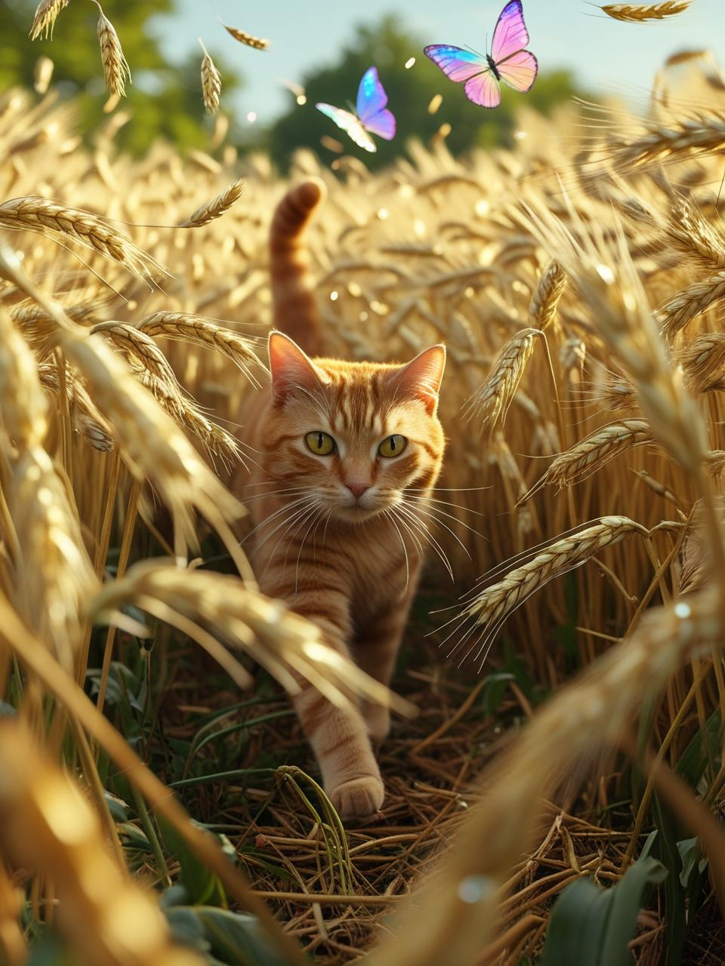

CHAPTER III
Exactly what the hunter expected happened. The cat came as usual to watch for the mouse, and caught sight of him running across the end of the path. The cat dashed after him; and just as she thought she really had got him this time, she found herself caught by the neck, for she had put her head into one of the snares. She was nearly strangled and could scarcely even mew. The mouse was so close that he heard the feeble mew, and in a terrible fright, thinking the cat was after him, he peeped through the stems of the barley to make sure which way to run to get away from her. What was his delight when he saw his enemy in such trouble and quite unable to do him any harm!

Now it so happened that the owl and the lizard were also in the barley-field, not very far away from the cat, and they too saw the distress their hated enemy was in. They also caught sight of the little mouse peeping through the barley; and the owl thought to himself, “I’ll have you, my little friend, now the cat cannot do me any harm,” whilst the lizard darted away into the sunshine, feeling glad that the cat and the owl were neither now likely to trouble their heads about him. The owl flew quietly to a tree close by to watch what would happen, feeling so sure of having the mouse for his dinner that he was in no hurry to catch him.

5. What would you have done if you had been the mouse, when you saw the cat in the snare?
6. Was the owl wise or foolish to wait before he caught the mouse?

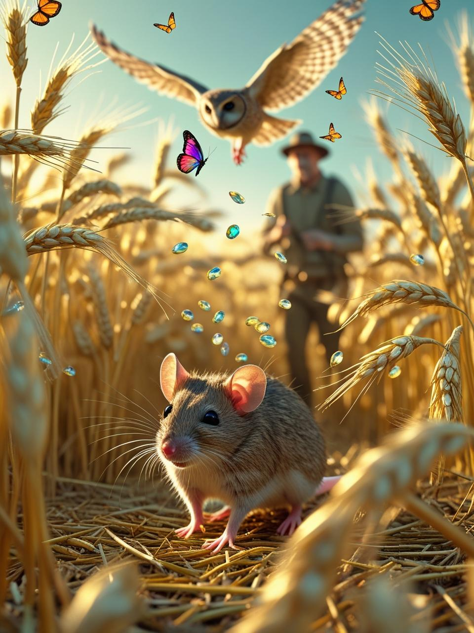

CHAPTER IV
The mouse, small and helpless though he was, was a wise little creature. He saw the owl fly up into the tree, and knew quite well that if he did not take care he would serve as dinner to that great strong bird. He knew too that, if he went within reach of the claws of the cat, he would suffer for it. “How I do wish,” he thought to himself, “I could make friends with the cat, now she is in distress, and get her to promise not to hurt me if ever she gets free. As long as I am near the cat, the owl will not dare to come after me.” As he thought and thought, his eyes got brighter and brighter, and at last he decided what he would do. He had, you see, kept his presence of mind; that is to say, he did not let his fright of the cat or the owl prevent him from thinking clearly. He now ventured forth from amongst the barley, and coming near enough to the cat for her to see him quite clearly, but not near enough for her to reach him with her claws, or far enough away for the owl to get him without danger from those terrible claws, he said to the cat in a queer little squeaky voice: “Dear Puss, I do not like to see you in such a fix. It is true we have never been exactly friends, but I have always looked up to you as a strong and noble enemy. If you will promise never to do me any harm, I will do my best to help you. I have very sharp teeth, and I might perhaps be able to nibble through the string round your beautiful neck and set you free. What do you think about it?”

7. Do you think there was any chance of a cat and a mouse becoming real friends?
8. Can you give two or three instances you know of presence of mind in danger?

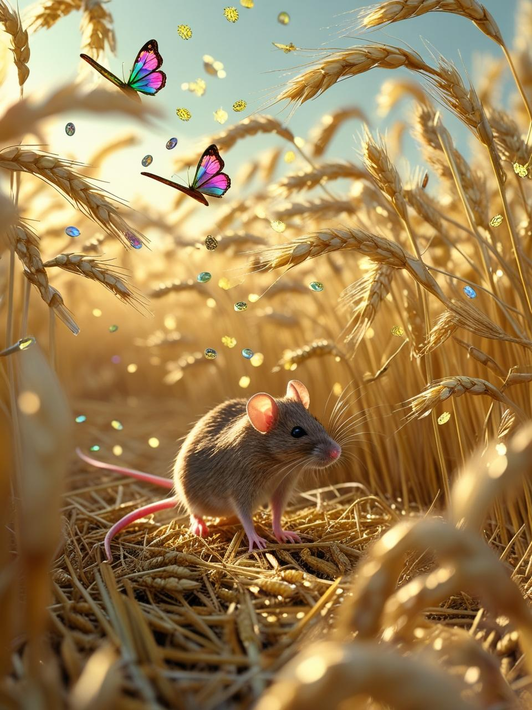

CHAPTER V
When the cat heard what the mouse said, she could hardly believe her ears. She was of course ready to promise anything to anyone who would help her, so she said at once:
“You dear little mouse, to wish to help me. If only you will nibble through that string which is killing me, I promise that I will always love you, always be your friend, and however hungry I may be, I will starve rather than hurt your tender little body.”
On hearing this, the mouse, without hesitating a moment, climbed up on to the cat’s back, and cuddled down in the soft fur near her neck, feeling very safe and warm there. The owl would certainly not attack him there, he thought, and the cat could not possibly hurt him. It was one thing to pounce down on a defenceless little creature running on the ground amongst the barley, quite another to try and snatch him from the very neck of a cat.
The cat of course expected the mouse to begin to nibble through the string at once, and became very uneasy when she felt the little creature nestle down as if to go to sleep, instead of helping her. Poor Pussy could not turn her head so as to see the mouse without drawing the string tighter, and she did not dare to speak angrily lest she should offend him. “My dear little friend,” she said, “do you not think it is high time to keep your promise and set me free?”
Hearing this, the mouse pretended to bite the string, but took care not to do so really; and the cat waited and waited, getting more miserable every minute. All through the long night the same thing went on: the mouse taking a little nap now and then, the cat getting weaker and weaker. “Oh,” she thought to herself, “if only I could get free, the first thing I would do would be to gobble up that horrid little mouse.” The moon rose, the stars came out, the wind murmured amongst the branches of the banyan tree, making the unfortunate cat long to be safe in her cosy home in the trunk. The cries of the wild animals which prowl about at night seeking their food were heard, and the cat feared one of them might find her and kill her. A mother tiger perhaps would snatch her, and take her to her hungry cubs, hidden away in the deep forest, or a bird of prey might swoop down on her and grip her in his terrible claws. Again and again she entreated the mouse to be quick, promising that, if only he would set her at liberty, she would never, never, never forget it or do any harm to her beloved friend.

9. What do you suppose the mouse was thinking all this time?
10. If you had been the mouse, would you have trusted to what the cat said in her misery?

CHAPTER VI
It was not until the moon had set and the light of the dawn had put out that of the stars that the mouse, made any real effort to help the cat. By this time the hunter who had set the snare came to see if he had caught the cat; and the poor cat, seeing him in the distance, became so wild with terror that she nearly killed herself in the struggle to get away. “Keep still! keep still,” cried the mouse, “and I will really save you.” Then with a few quick bites with his sharp teeth he cut through the string, and the next moment the cat was hidden amongst the barley, and the mouse was running off in the opposite direction, determined to keep well out of sight of the creature he had kept in such misery for so many hours. Full well he knew that all the cat’s promises would be forgotten, and that she would eat him up if she could catch him. The owl too flew away, and the lizard went off to hunt flies in the sunshine, and there was not a sign of any of the four inhabitants of the banyan tree when the hunter reached the snare. He was very much surprised and puzzled to find the string hanging loose in two pieces, and no sign of there having been anything caught in it, except two white hairs lying on the ground close to the trap. He had a good look round, and then went home without having found out anything.

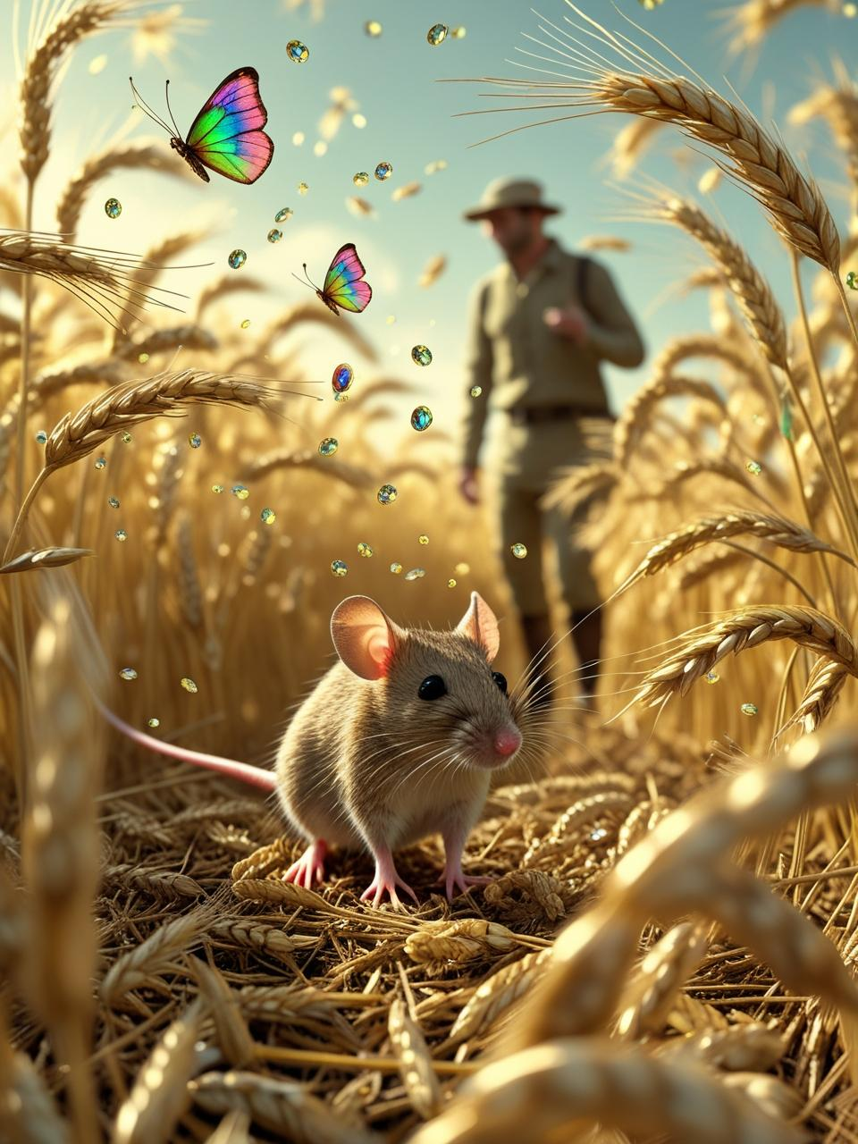

When the hunter was quite out of sight, the cat came forth from the barley, and hastened back to her beloved home in the banyan tree. On her way there she spied the mouse also hurrying along in the same direction, and at first she felt inclined to hunt him and eat him then and there. On second thoughts however she decided to try and keep friends with him, because he might help her again if she got caught a second time. So she took no notice of the mouse until the next day, when she climbed down the tree and went to the roots in which she knew the mouse was hidden. There she began to purr as loud as she could, to show the mouse she was in a good humour, and called out, “Dear good little mouse, come out of your hole and let me tell you how very, very grateful I am to you for saving my life. There is nothing in the world I will not do for you, if you will only be friends with me.”
The mouse only squeaked in answer to this speech, and took very good care not to show himself, till he was quite sure the cat was gone beyond reach of him. He stayed quietly in his hole, and only ventured forth after he had heard the cat climb up into the tree again. “It is all very well,” thought the mouse, “to pretend to make friends with an enemy when that enemy is helpless, but I should indeed be a silly mouse to trust a cat when she is free to kill me.”
The cat made a good many other efforts to be friends with the mouse, but they were all unsuccessful. In the end the owl caught the mouse, and the cat killed the lizard. The owl and the cat both lived for the rest of their lives in the banyan tree, and died in the end at a good old age.

11. Do you think it is ever possible to make a real friend of an enemy?
12. What do you think the mouse deserved most praise for in his behaviour?
13. Which of the four animals in this story do you like best and which do you dislike most?
14. Can an animal be blamed for acting according to its nature? For instance, can you call it cruel for a cat or an owl to kill and eat a mouse?
15. Is it always right to forgive an injury?

- THE END -

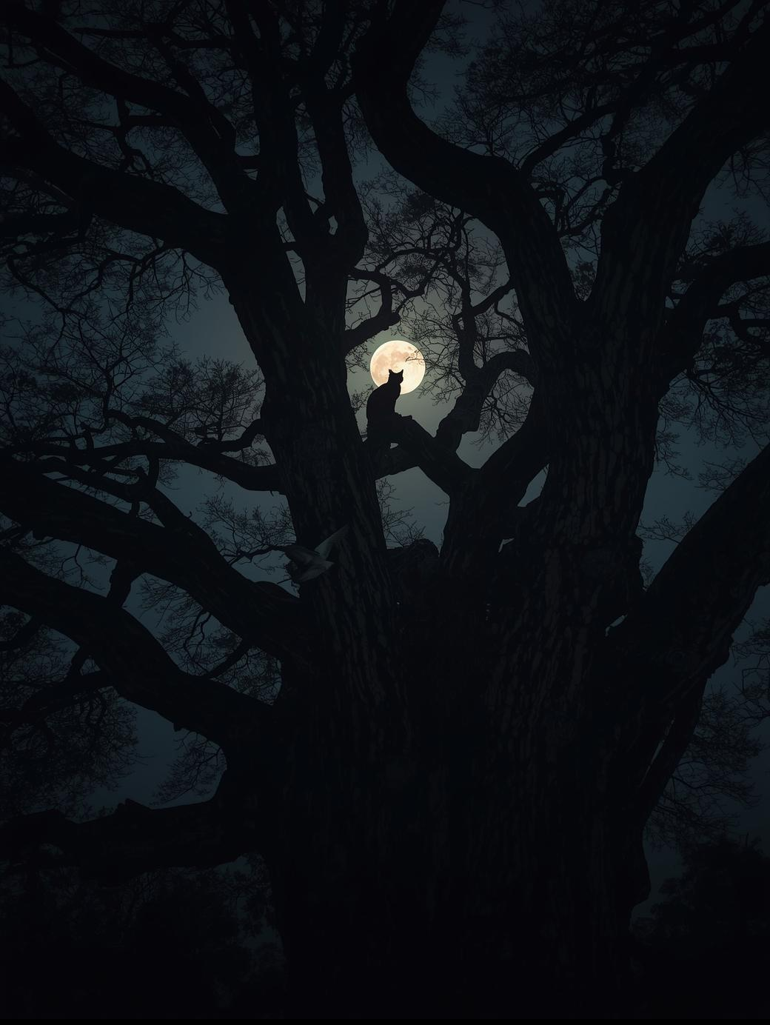
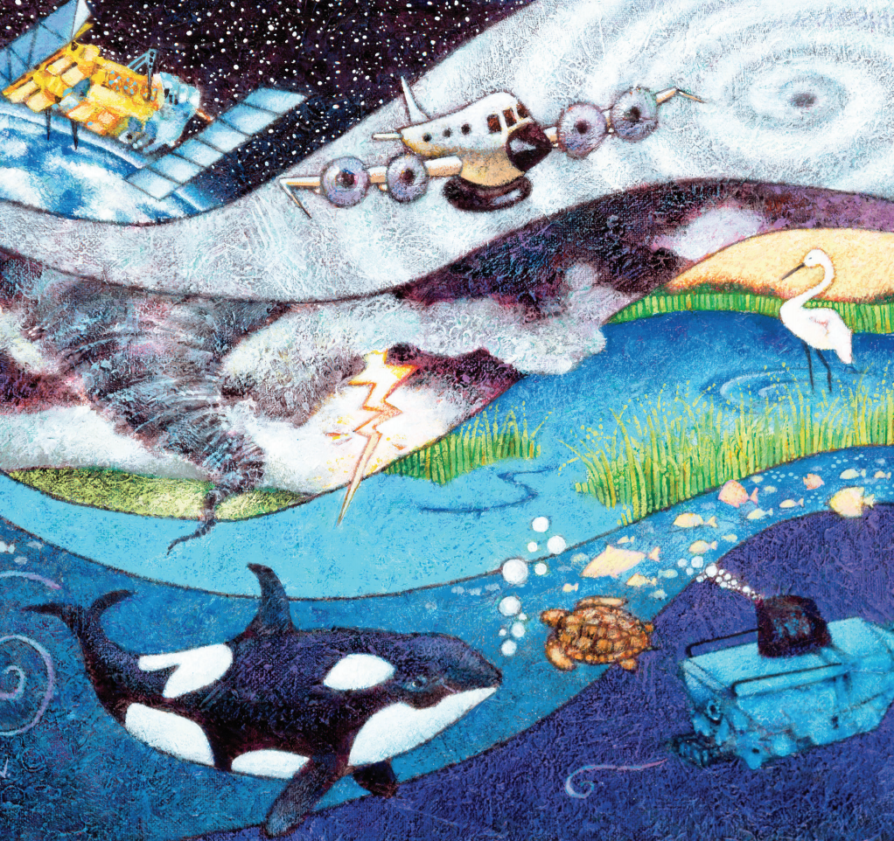
Legal Notice: This book is in PUBLIC DOMAIN- YAY!!! That means you can reuse it in pretty much any way you wish. We greatly appreciate if you credit to us as a source by including a link to our site, https://www.freekidsbooks.org, on your post or end product, or simply leave this page in tact, so more people can enjoy great free books, but it is not mandatory. Please reach out and contact us https://www.freekidsbooks.org/about if you want more information, or want to share your project with us, so we can help with promotion. Please, enjoy this, and our many more free kids books!
https://www.freekidsbooks.org
Simply great free books -
Preschool, early grades, picture books, learning to read,
early chapter books, middle grade, young adult,
Pratham, Book Dash, Mustardseed, Open Equal Free, and many more!
Always Free – Always will be!

Want to find more great books
like this one?
More great
free kids
ebooks?

